Medicure

Healthcare Domain

This project is developing an application which interacts about healthcare parameters.

1. Git - For version control for tracking changes in the code files .
2. Jenkins - For continuous integration and continuous deployment .
3. Docker - For containerizing applications .
4. Ansible - Configuration management tools.
5. Selenium - For automating tests on the deployed web application.
6. Terraform - For creation of infrastructure.
7. Kubernetes – for running containerized application in managed cluster.

Here is the EC2 server created with following specifications to act as master server. It is configured with java, maven, docker, Jenkins, Ansible and Terraform on the instance, this server acts as master server, which is used to implement CI/CD pipeline script.

Public IP: *3.110.151.185*

IAM Role: srija with EC2 Full Access.

Java Version: jdk-17

Maven version: maven 3.6.3.

Ansible Version: 2.14.5

Terraform Version: v1.4.6

Docker Version: 20.10.21

Jenkins configured on URL: *3.110.151.185:8080*

This is the EC2 dashboard showing that master-server is up and running.

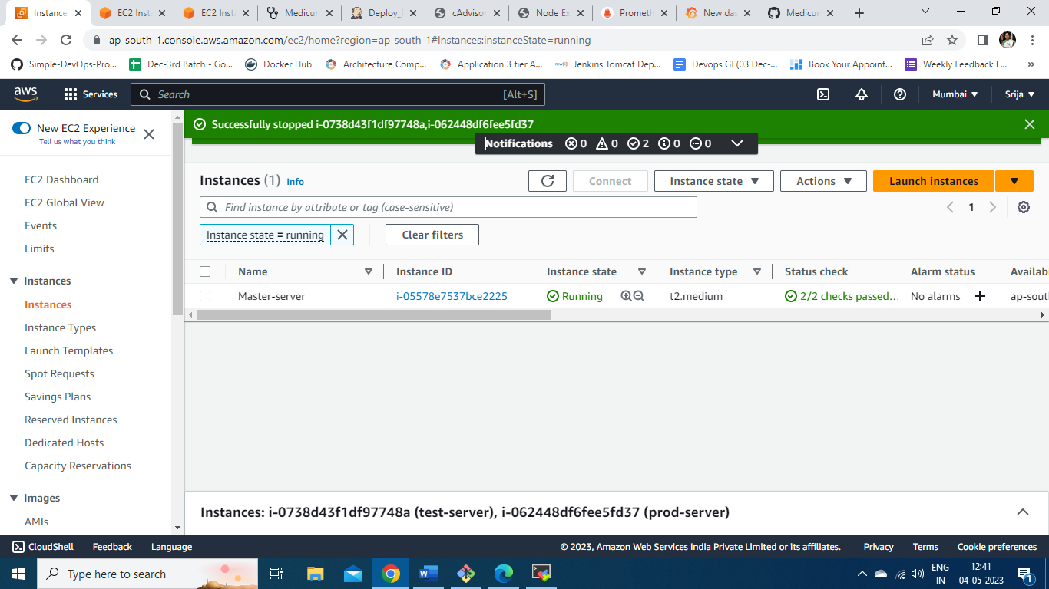

Here is the screenshot of IP address of master server configuration.

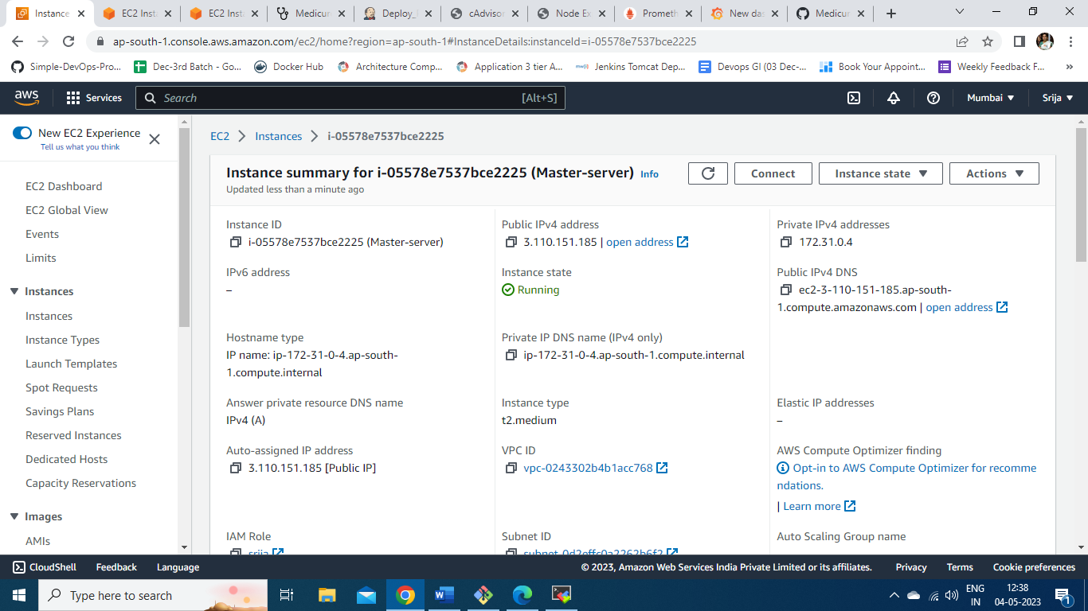

This is the figure showing master server is connected through SSH connection using mobaxterm and all the software packages installed with their versions and status.

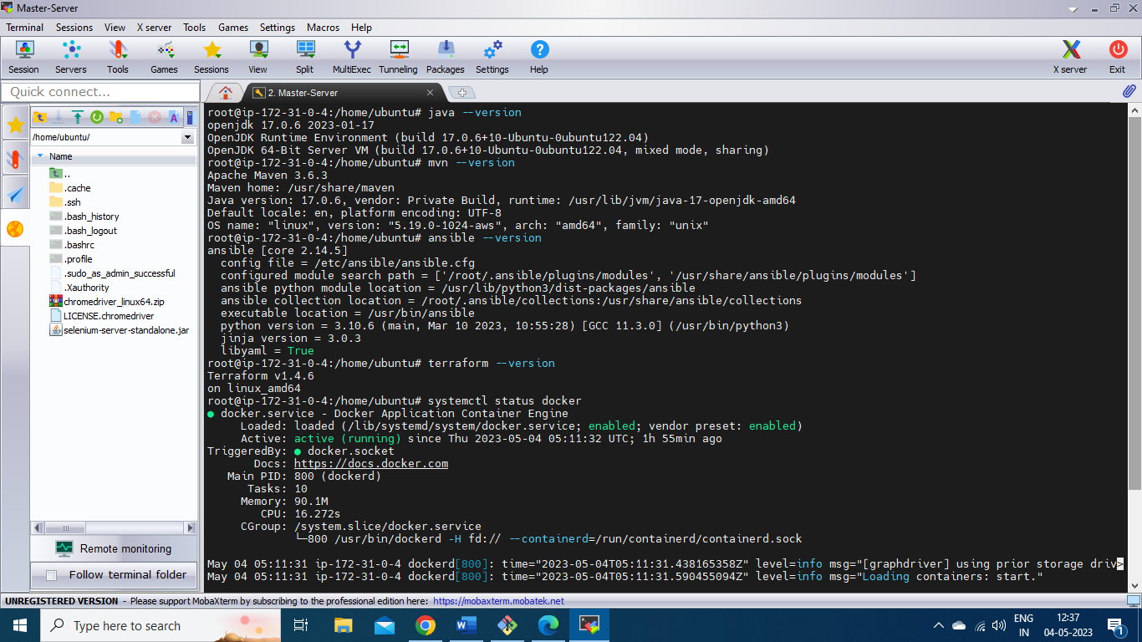

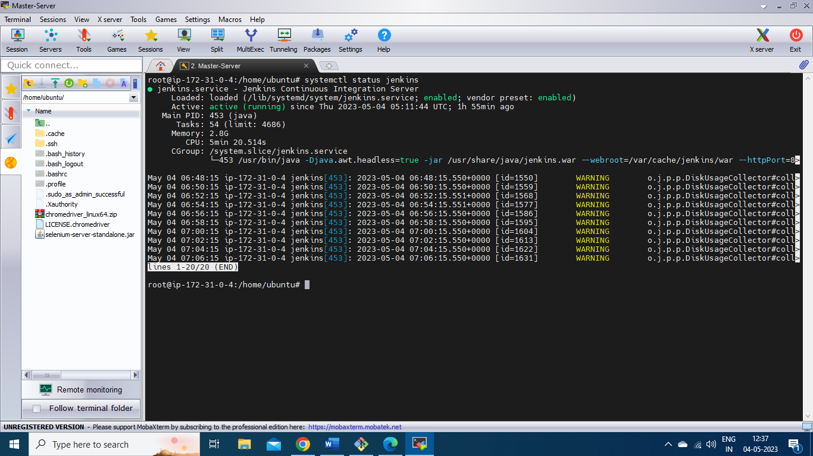

Jenkins is accessed on URL : 3.110.151.185:8080 port and a new job is created named ***Medicure*** to build the packages using maven build tool, then create docker image out of it using ***Docker file***  and then push the docker image onto Docker hub and use the image later to create a deployment on test server created using terraform and configured using ansible tool.

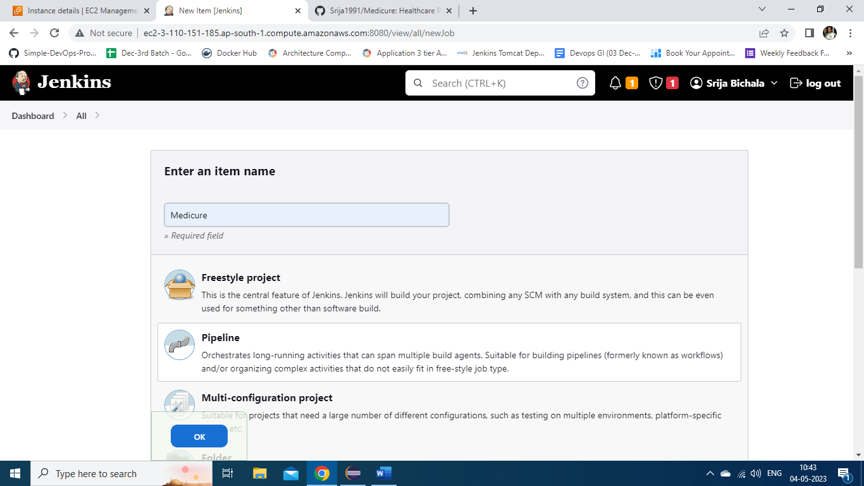

Here is the description of job Medicure.

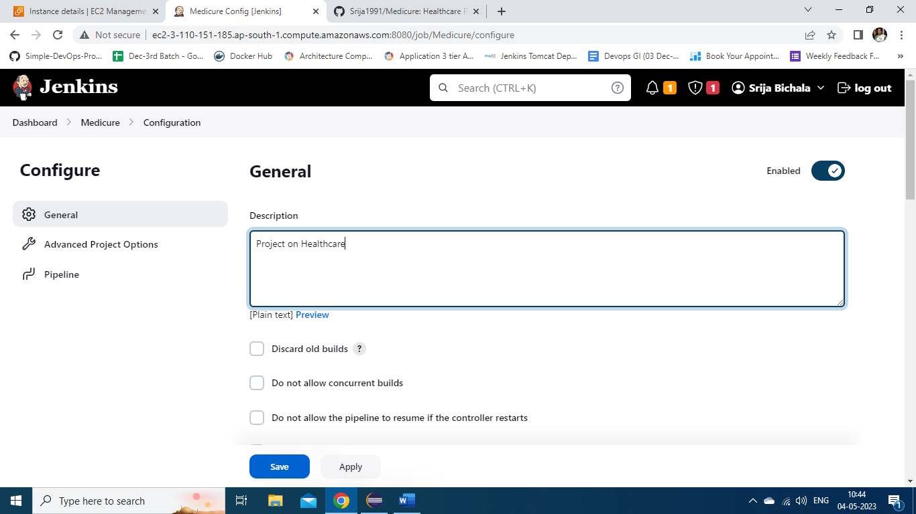

The source code for this job is fetched through Git hub and the file name to execute pipeline script is “***Jenkinsfile***”.

Git URL: https://github.com/Srija1991/Medicure.git.

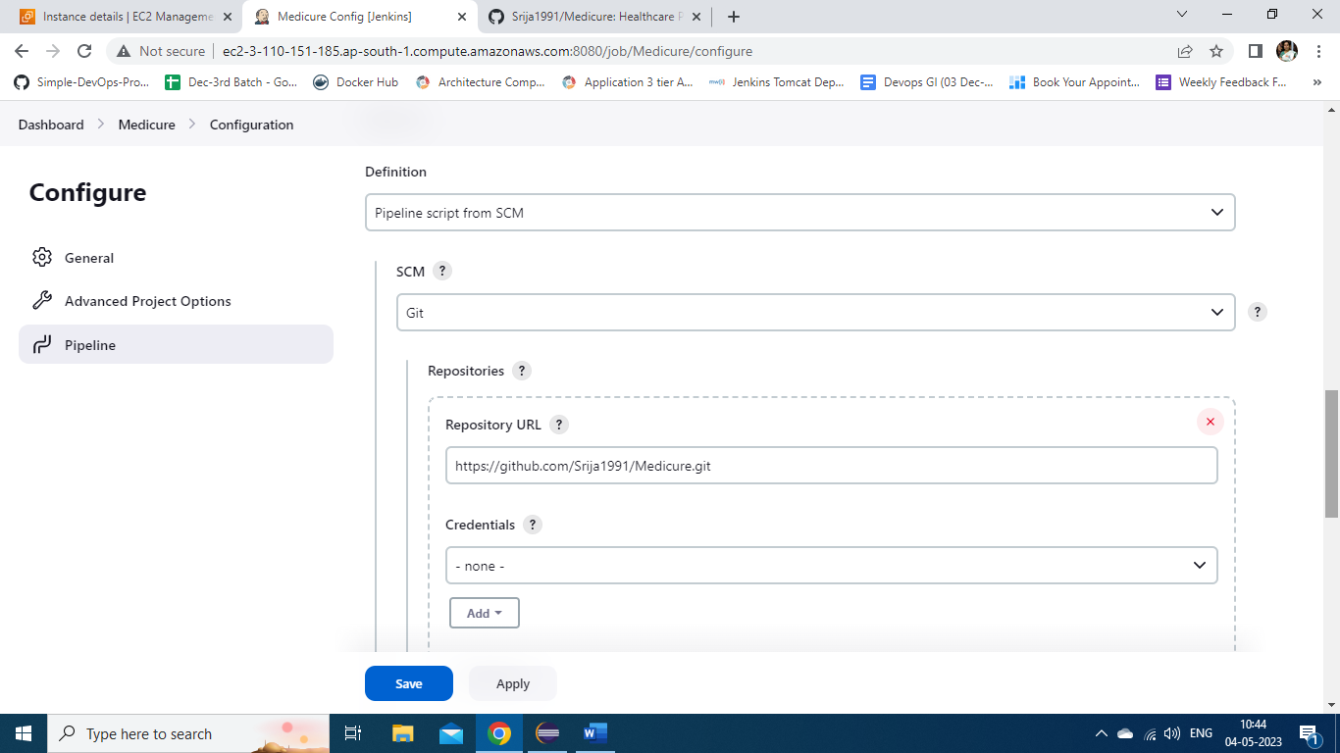

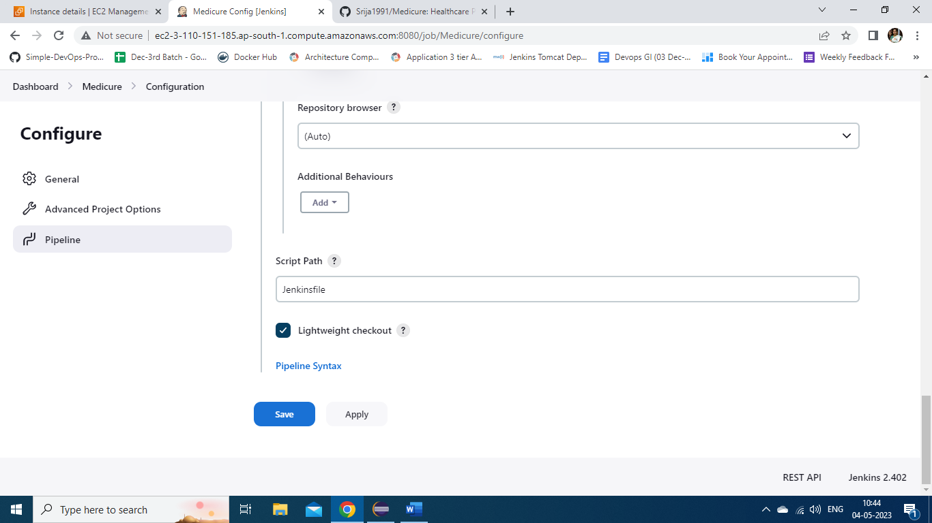

Here is Jenkins file illustrating the flow of CI/CD pipeline.

Stage 1: Git checkout : Use the code available on git URL mentioned in the file Jenkinsfile.

Stage2: Build the application using maven command “*mvn clean package*”.

Stage 3: Publish the test reports using HTML publisher.

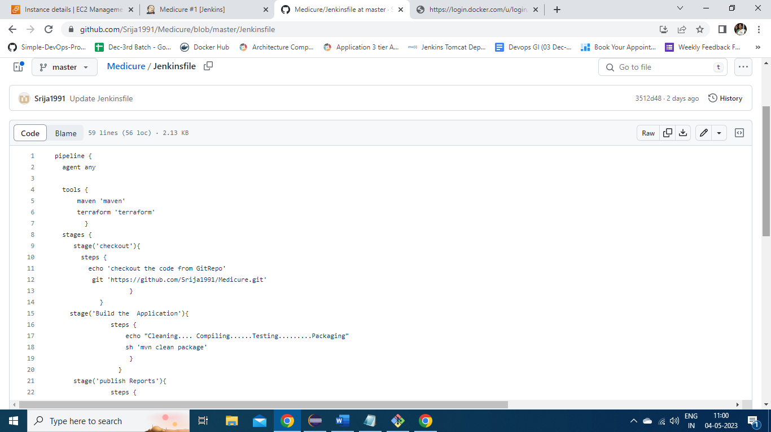

Stage 4: Create docker image using the Dockerfile and jar file created from build success step.

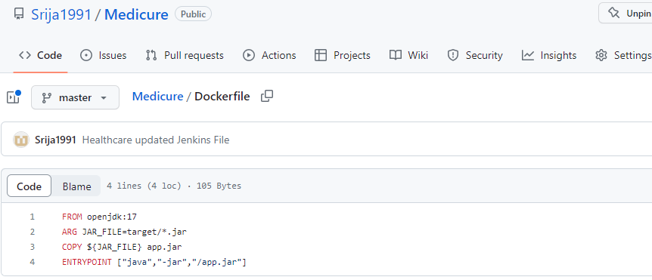

Stage 5: Push the docker mage onto docker hub using appropriate credentials with the name *srija1991/medicure*.

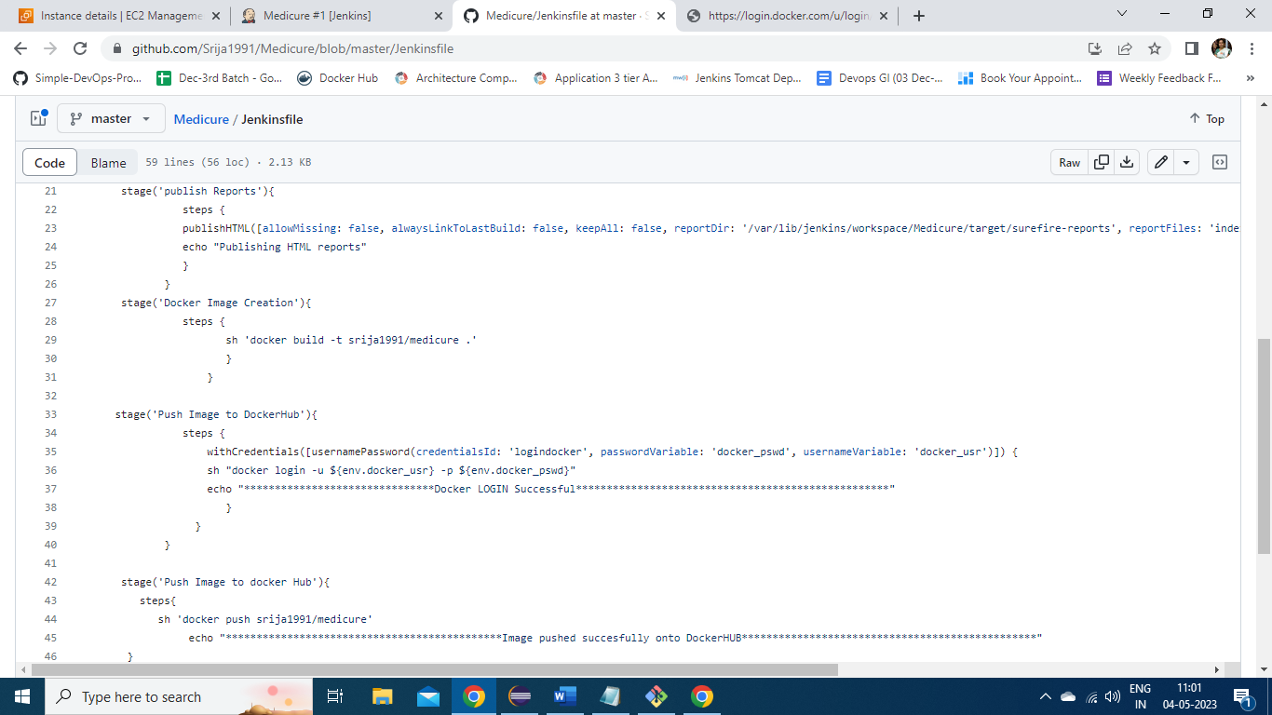

Now stage 6 is used to create an EC2 instance which acts as a test -server. Here is test-server folder which has *main.tf* file to create an EC2 instance in the region mentioned and attach the keypair *“apr26*”.

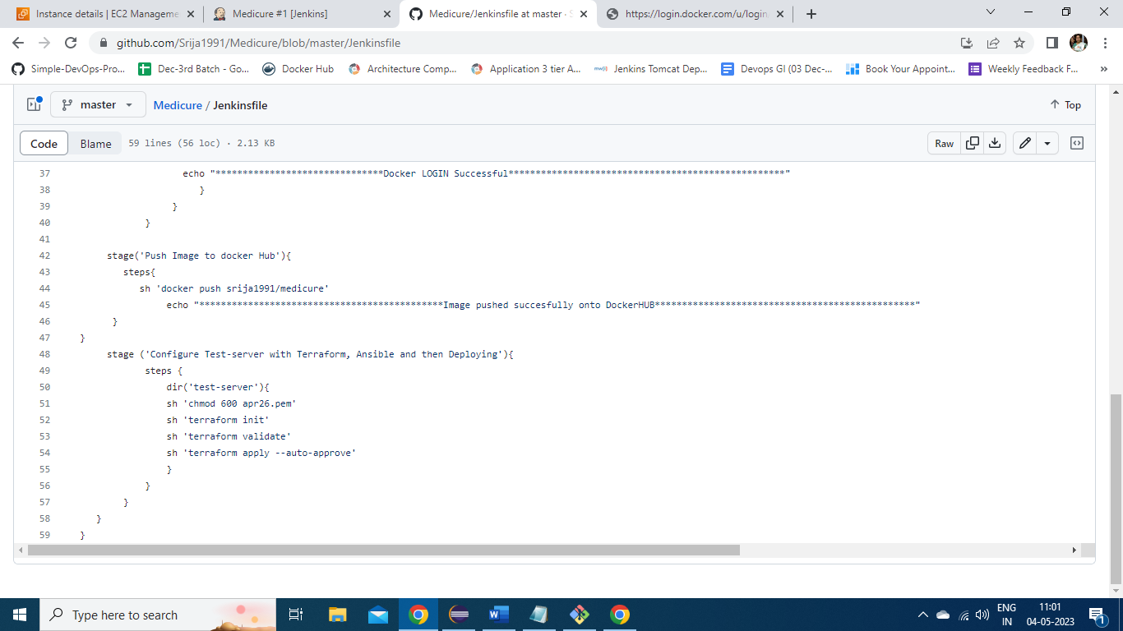

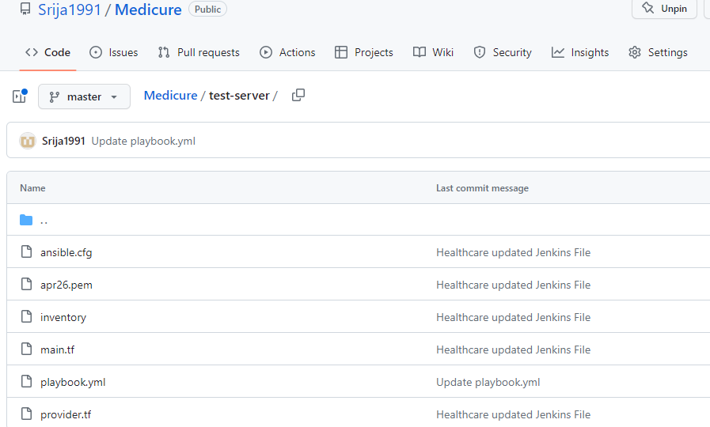

*Main.tf* file with the terraform script for creating test-server and run ansible playbook to install necessary packages to deploy application onto it.

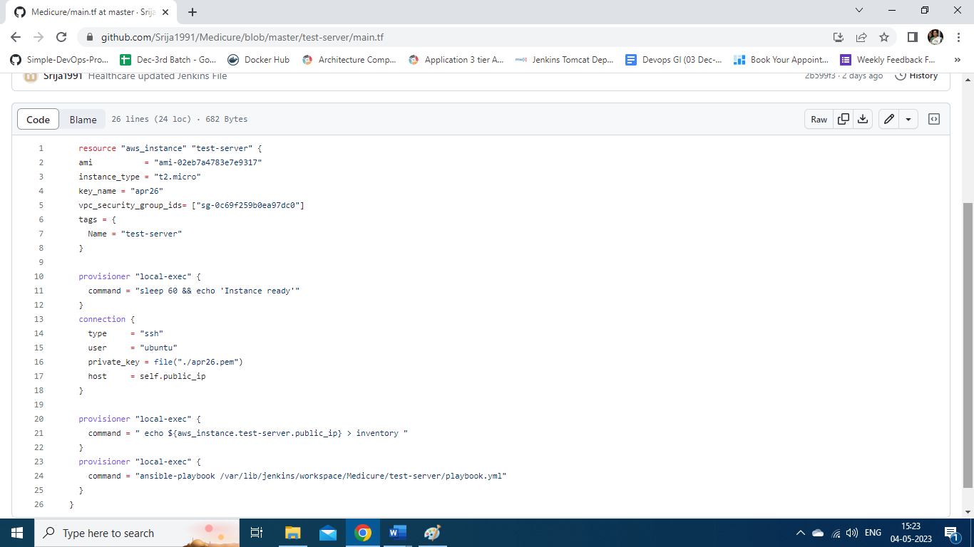

Here is *playbook.yml* to configure the test-server created and deploy the application on port number 8084.

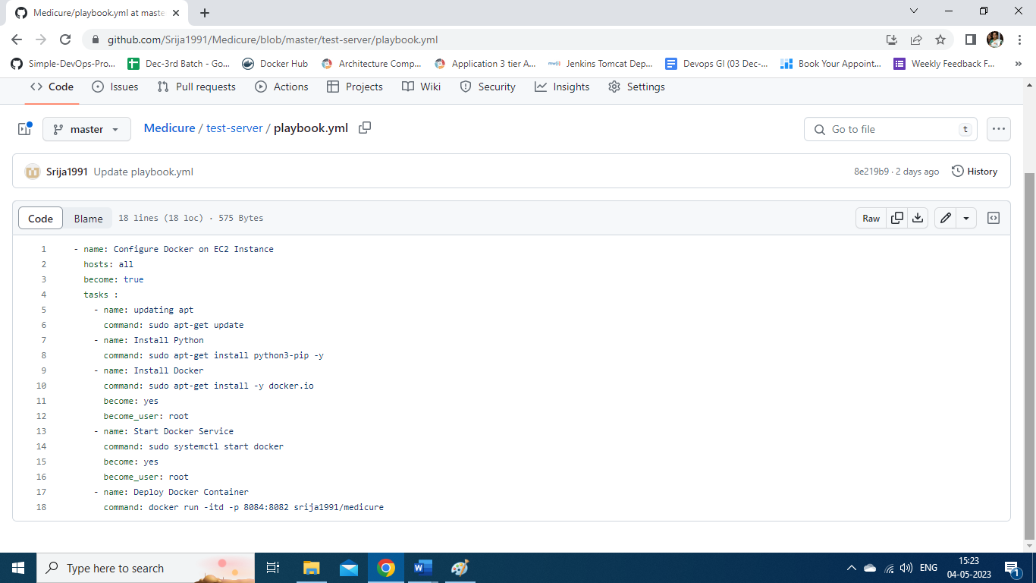

Now the job is build sucessfully and here is console output .

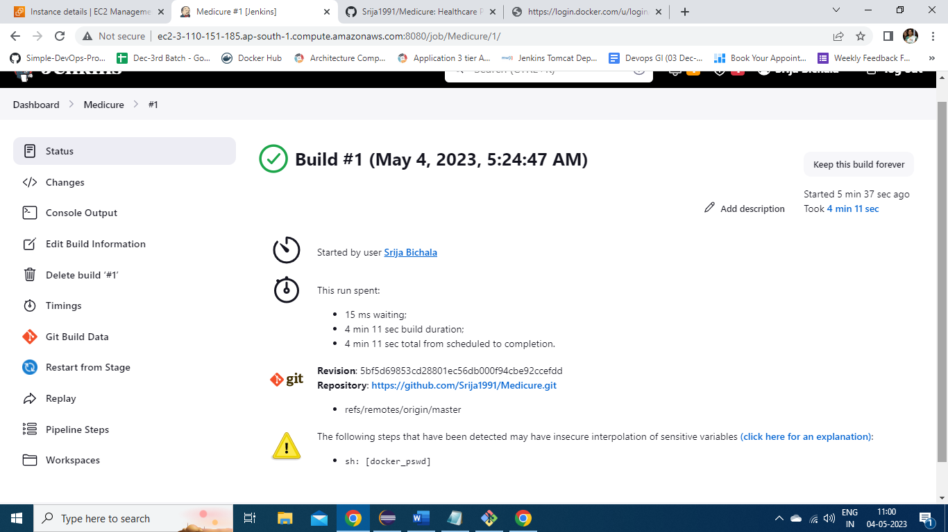

The git checkout is sucessful.

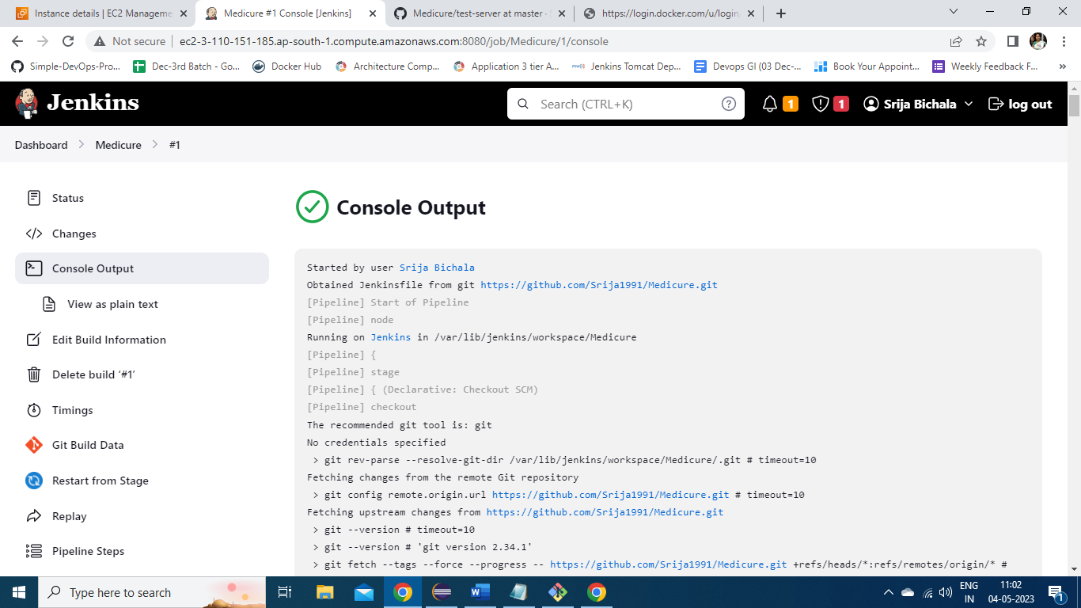

Stage 2 Build the package is successful.

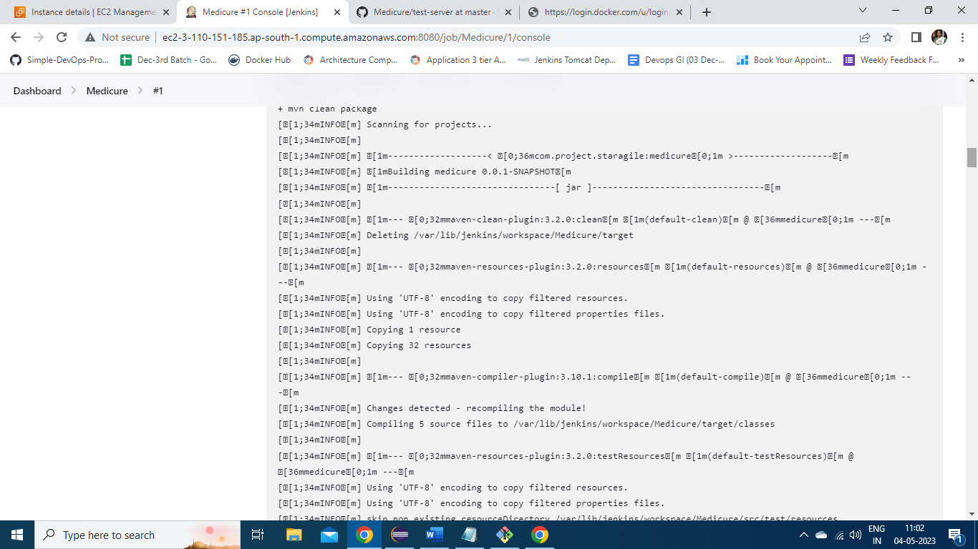

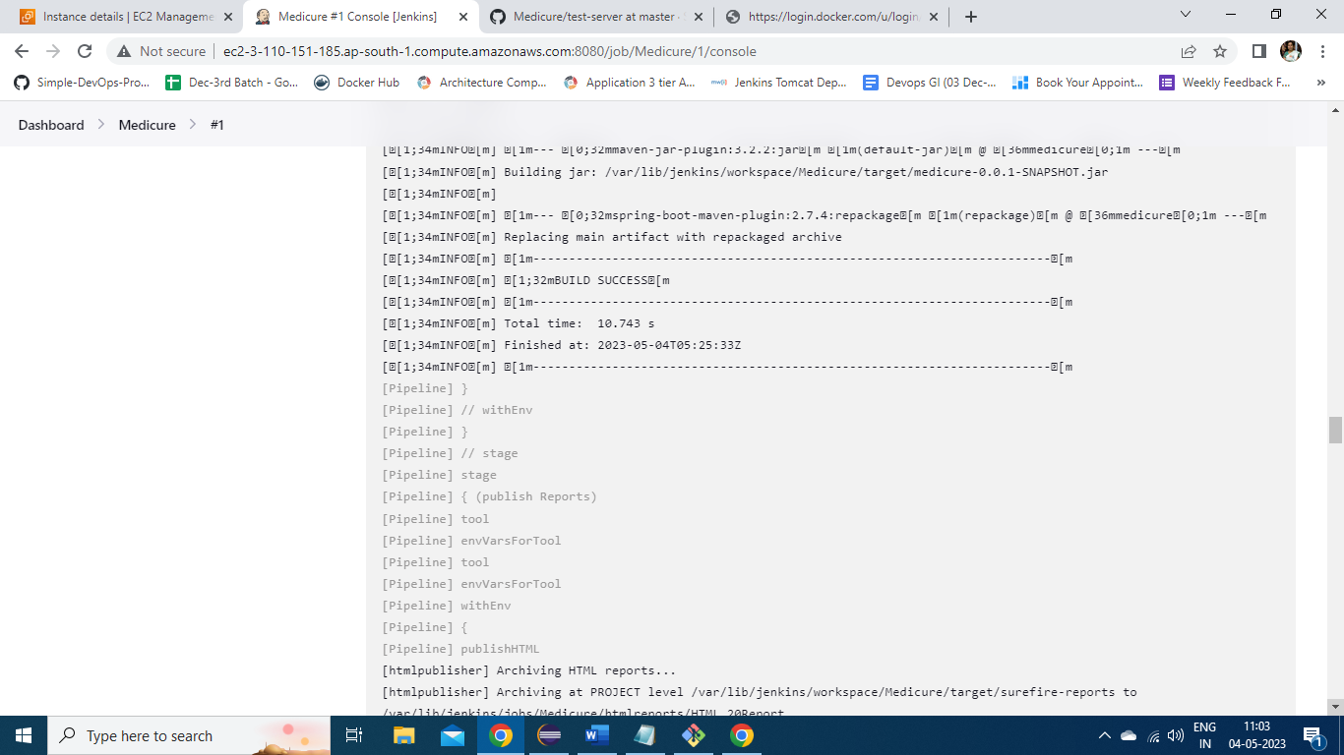

Stage 3: Published the reports to specified folder.

Stage 4: Docker image is created.

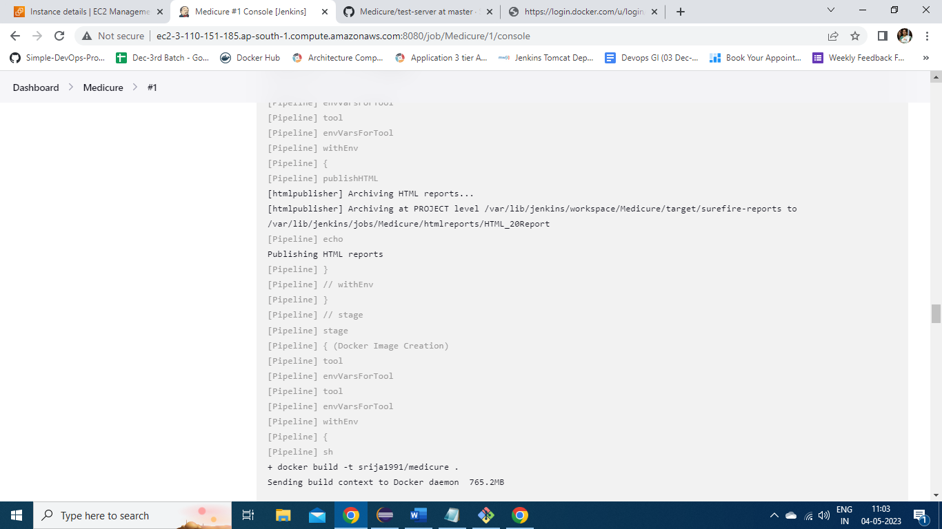

Image is pushed successfully onto docker hub.

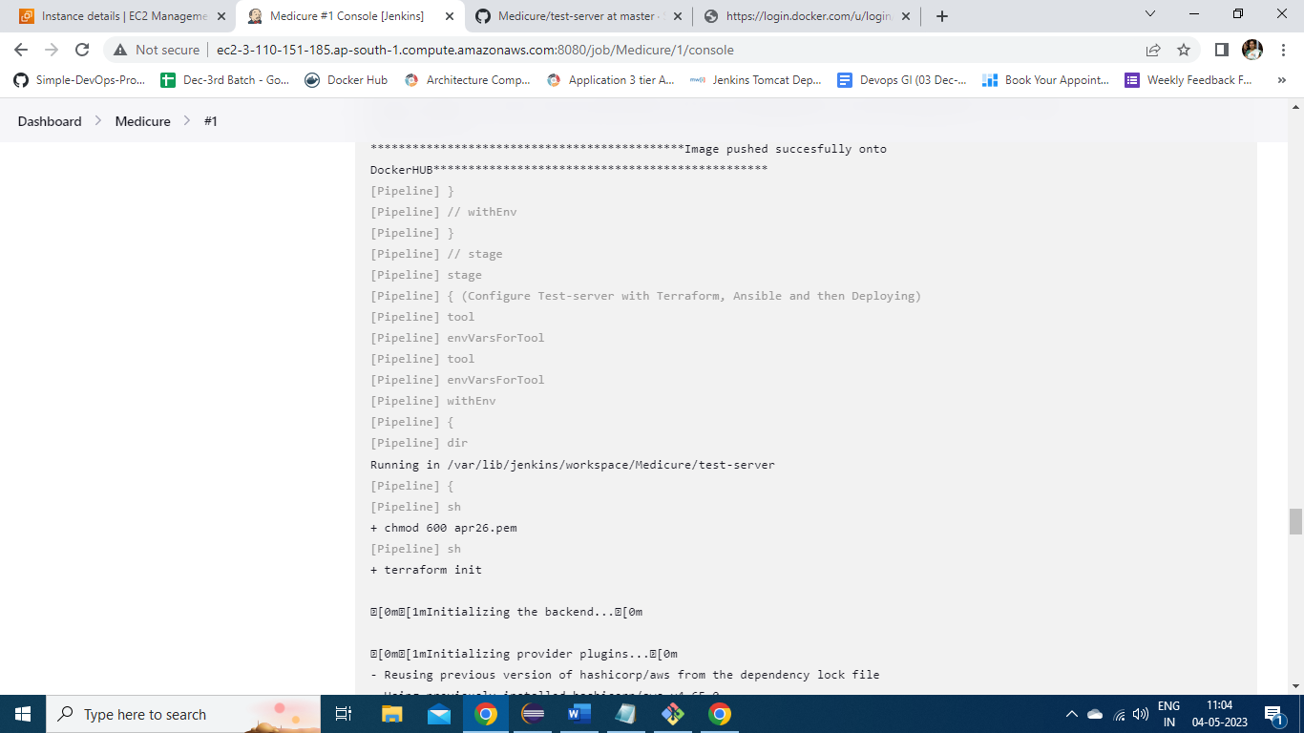

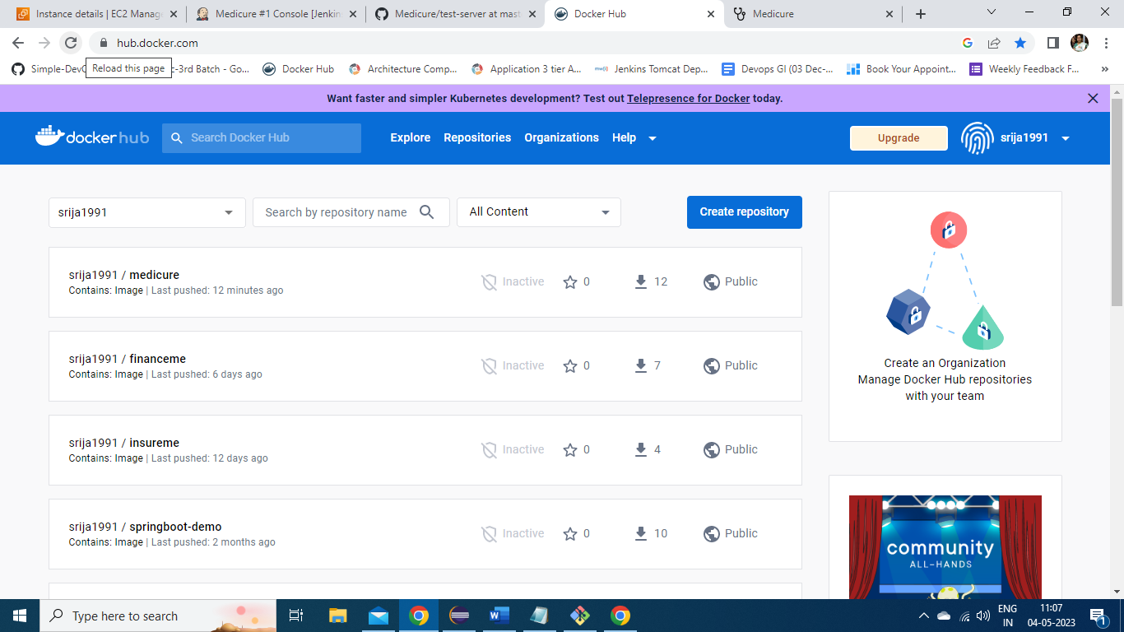

Terraform is initiated and test -server is created with Public IP: 13.126.21.109

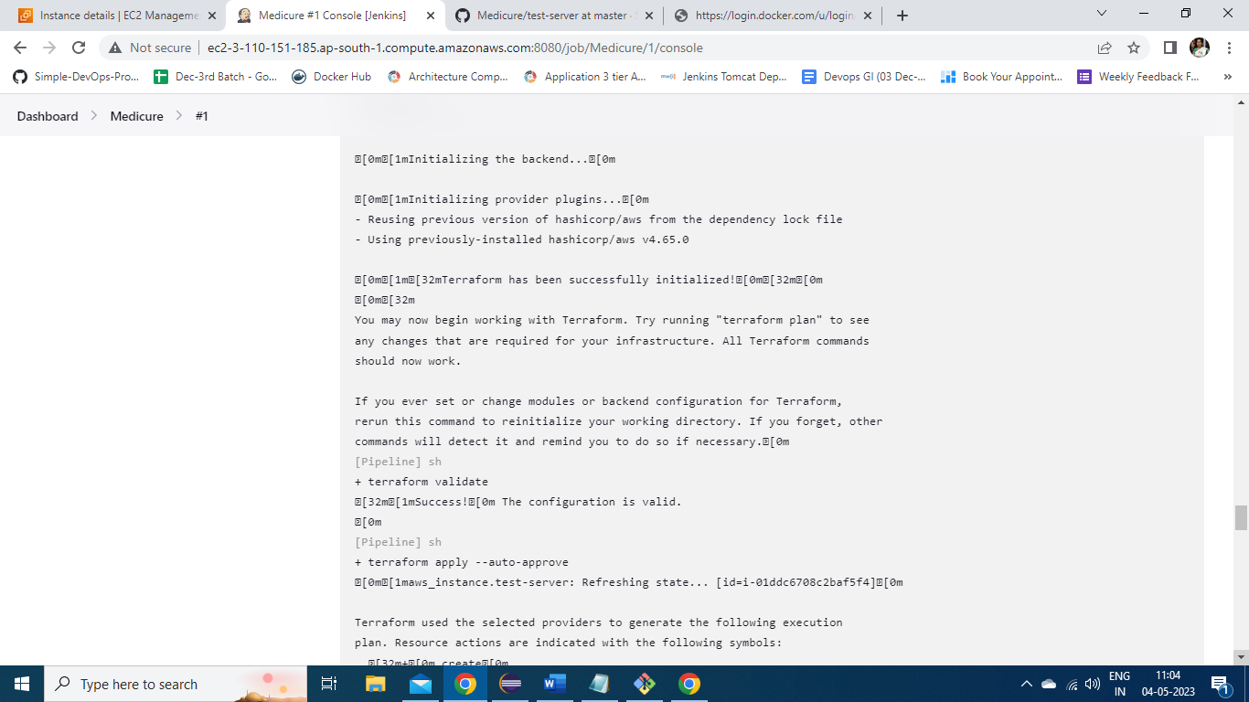

The playbook to configure test-server is started and completed successfully.

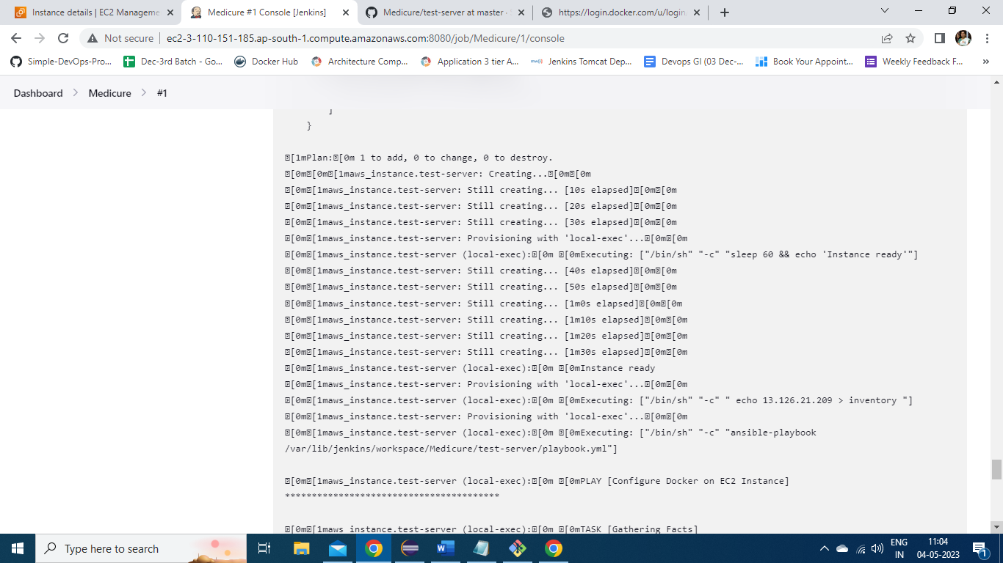

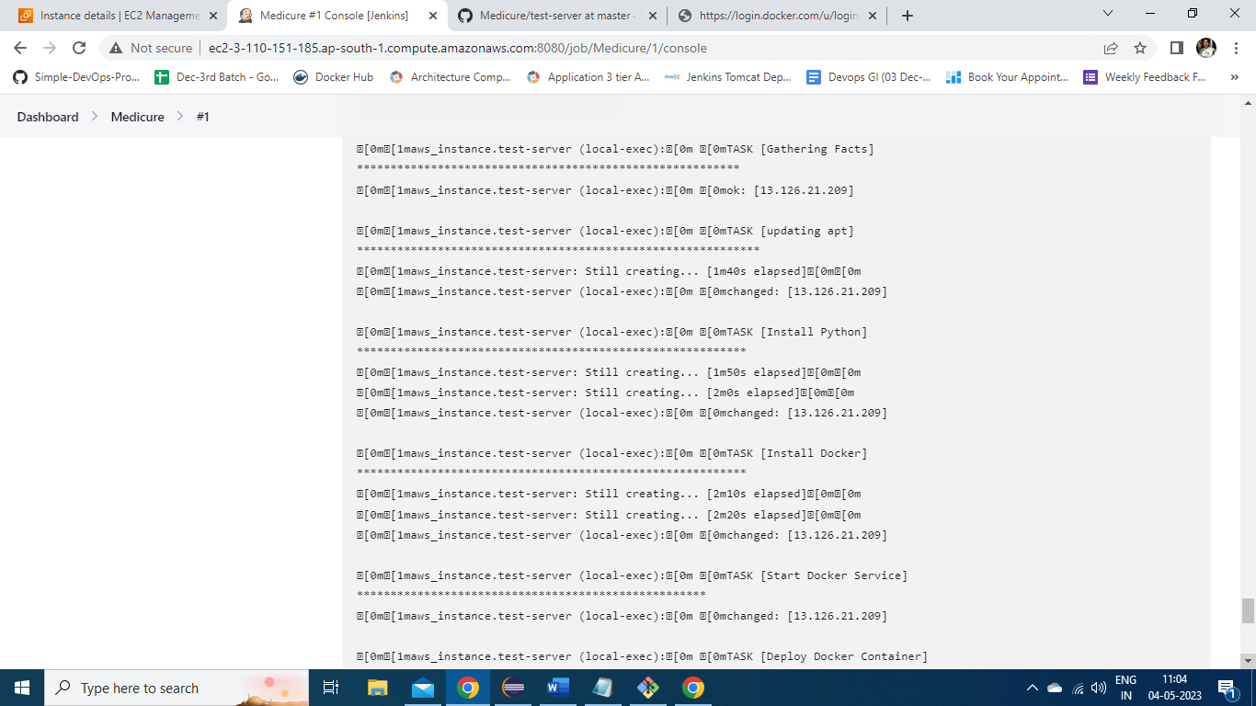

The application is successfully deployed on to the port 8084 and it triggers the selenium test for the server.

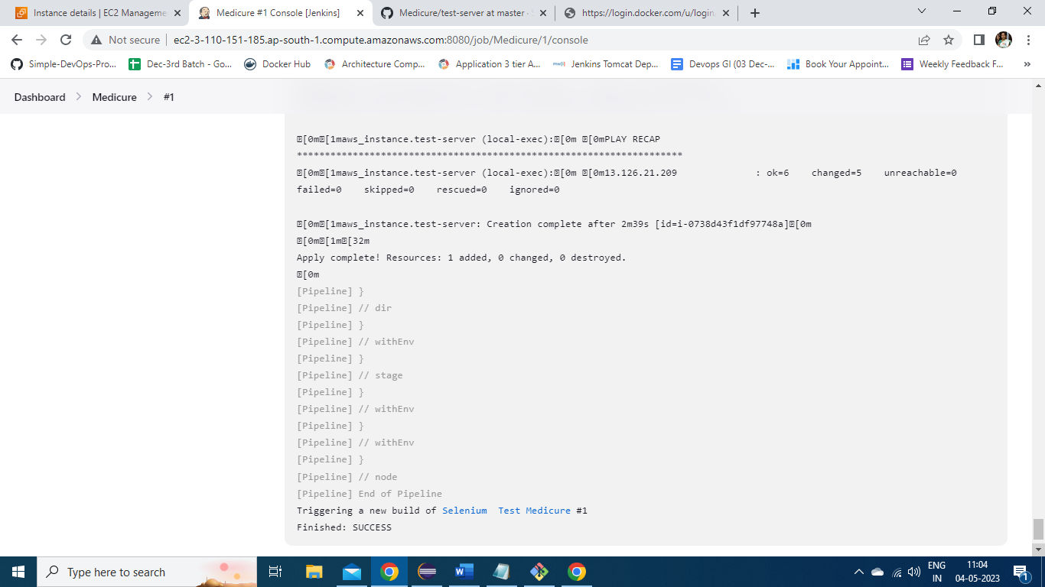

Here is the created test-server using terraform and the IP details of test-server are shown here.

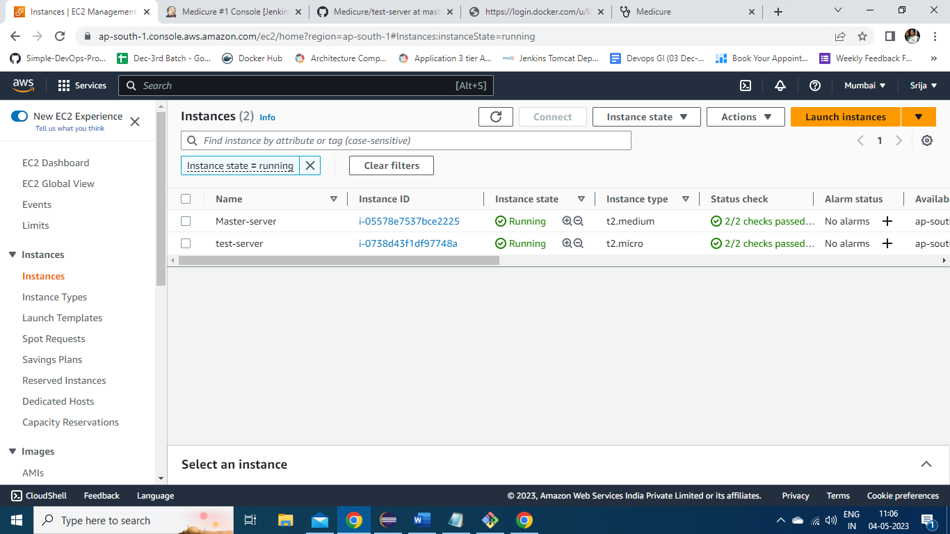

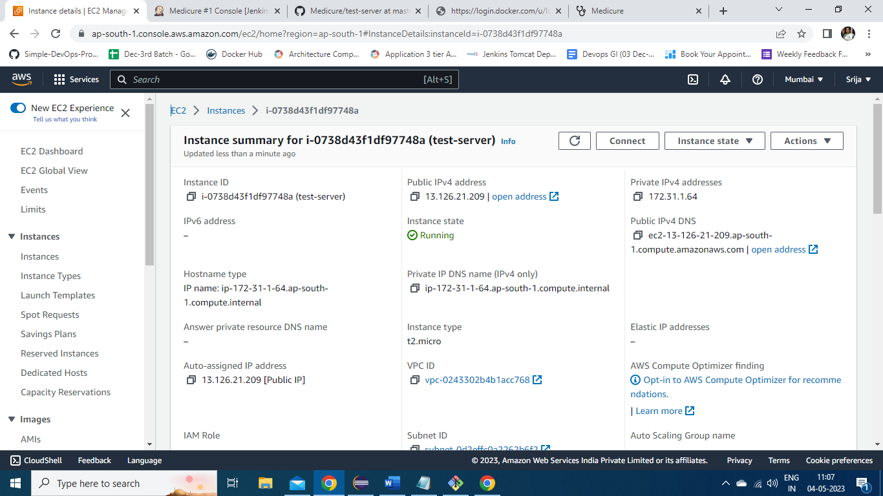

The application on test-server: 13.126.21.109:8084



Here is the selenium script written in eclipse to test the deployed application on test-server contacts page.

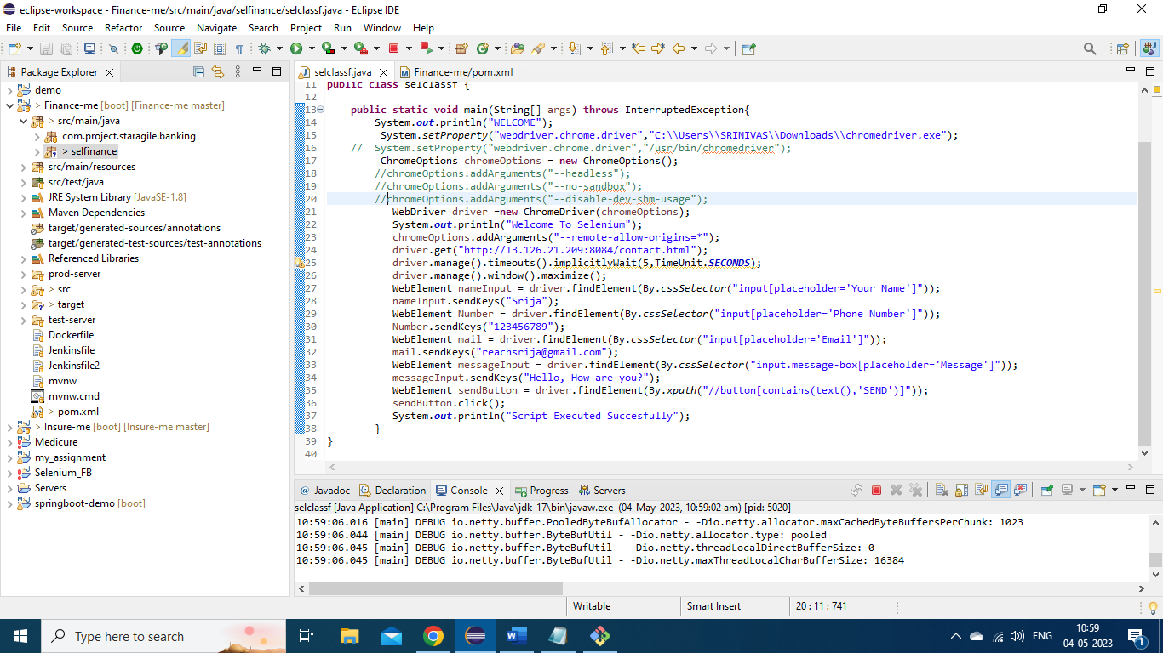

This selenium script is run as java application to test the working of it on windows platform.

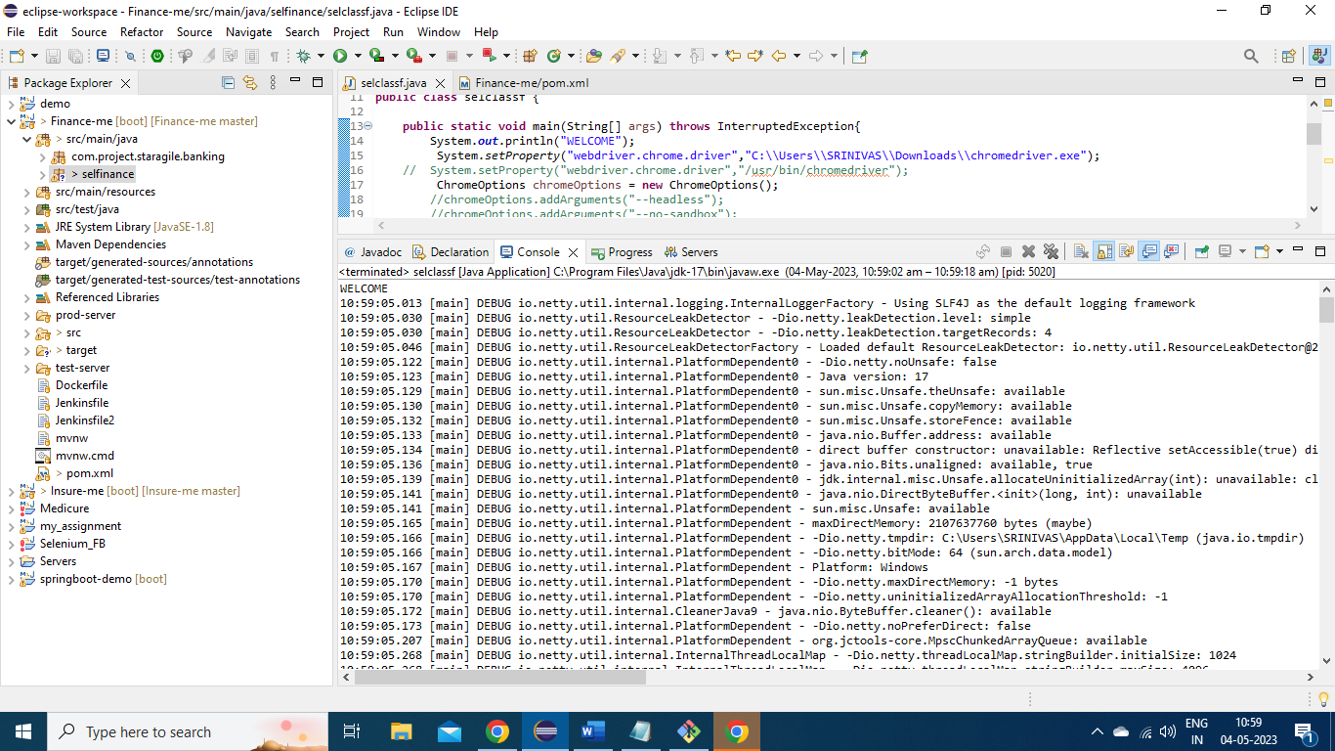

Here is it is successfully started and it automates the application and enters the basic details of a customer willing to contact the Medicure.

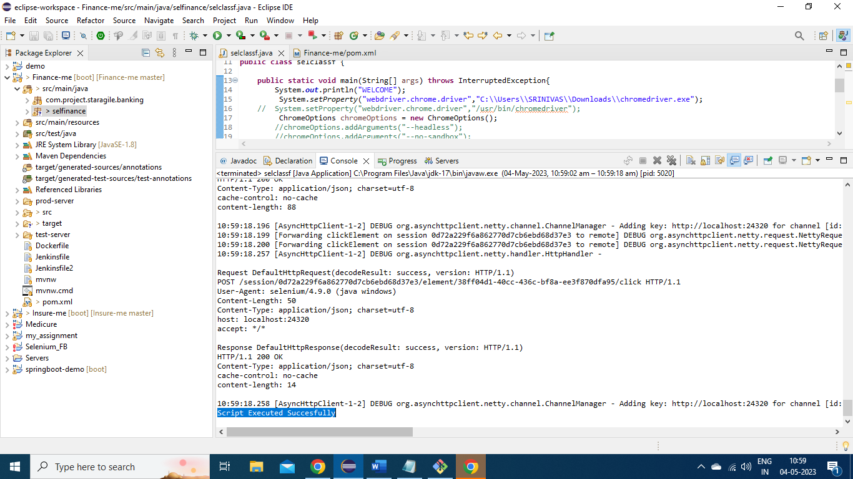

Here is the automated application run though selenium.

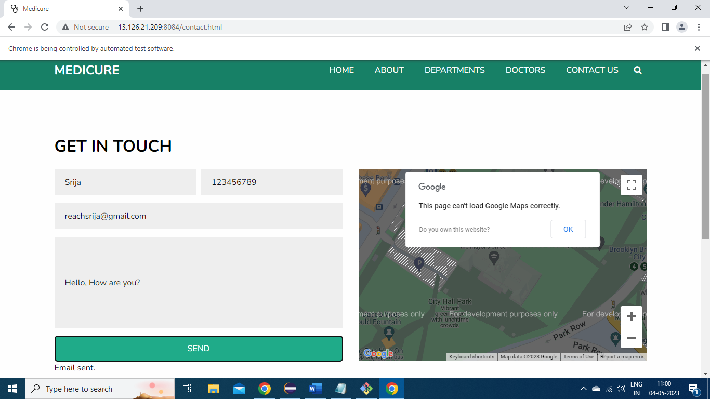

Now the selenium script is modified to run on Linux platform and exported as runnable jar to git hub .

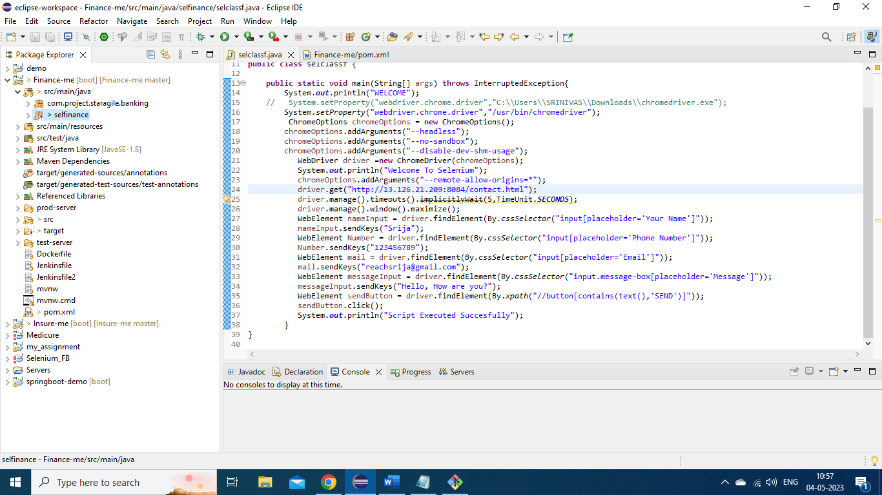

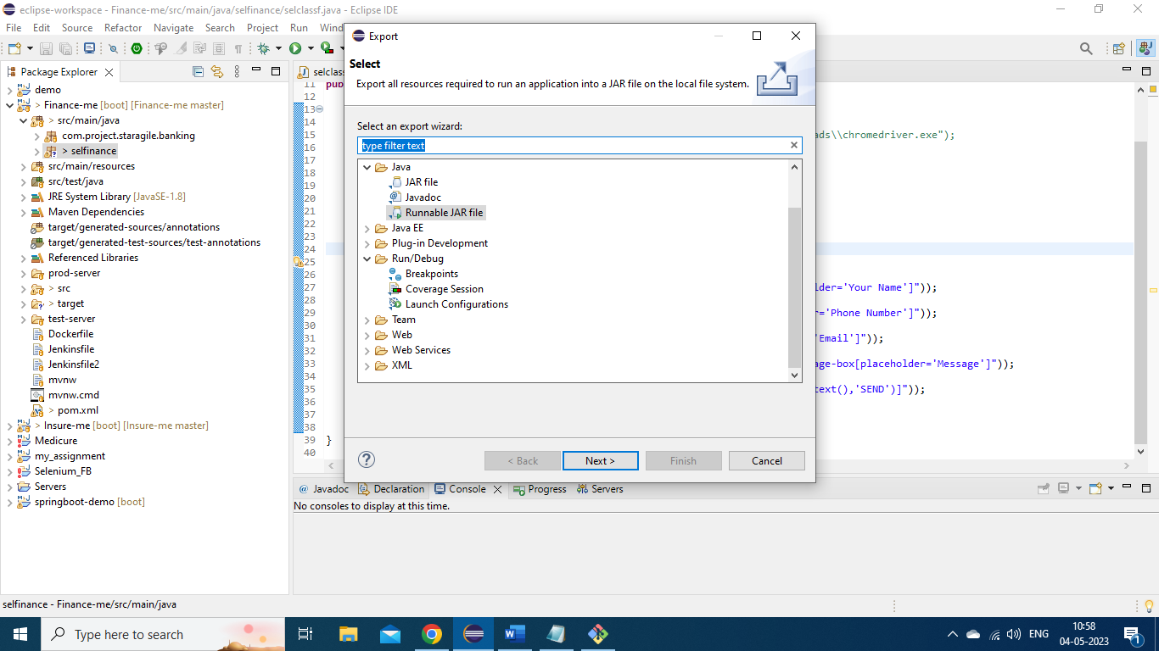

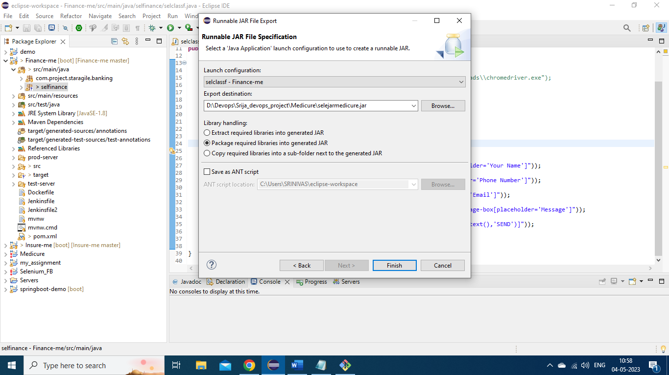

The exported jar is pushed onto GitHub to execute the selenium script on EC2 instance.

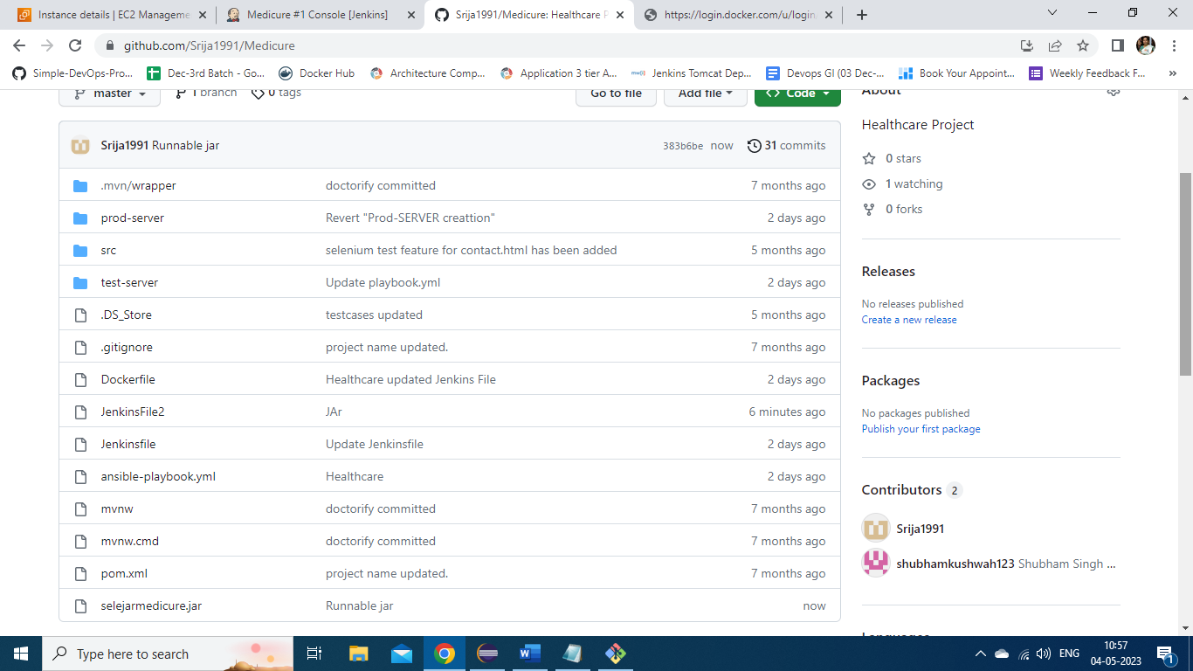

A new job named Selenium Test Medicure is created to run the selenium script after the successful execution of Medicure job.

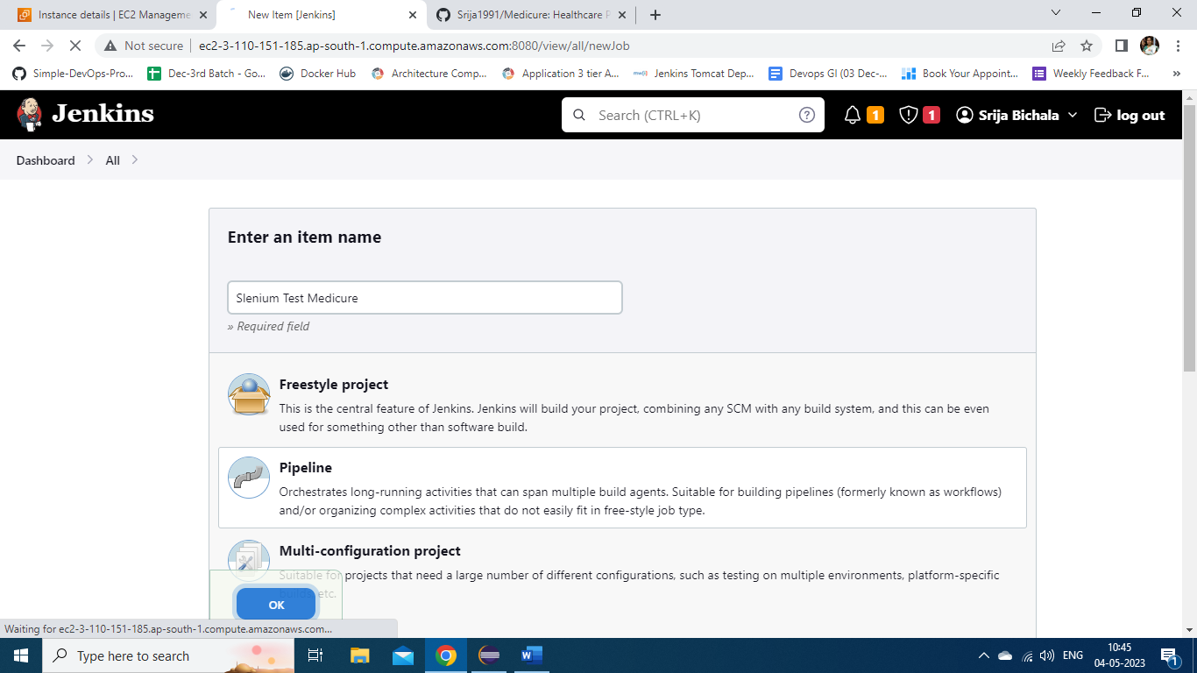

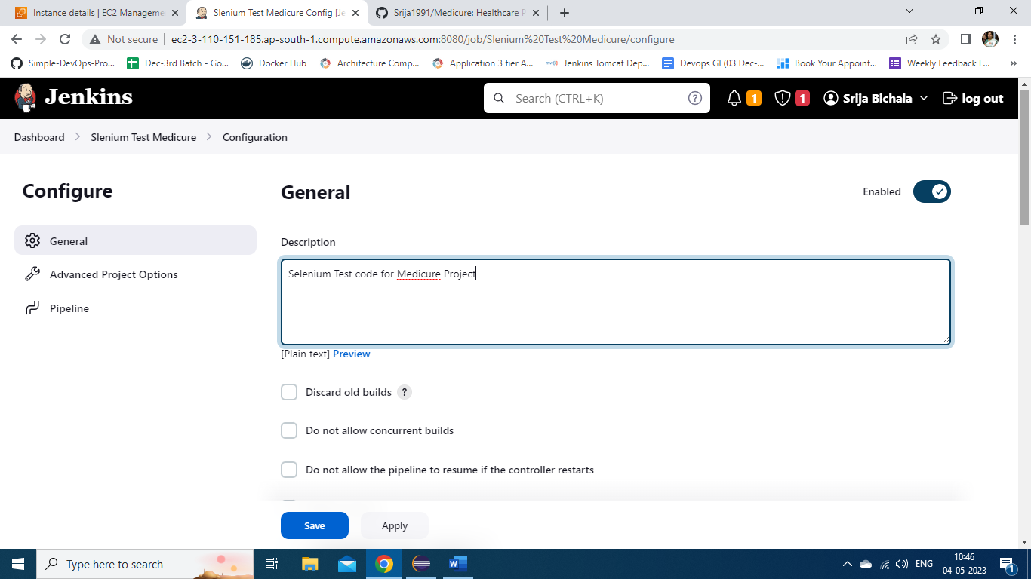

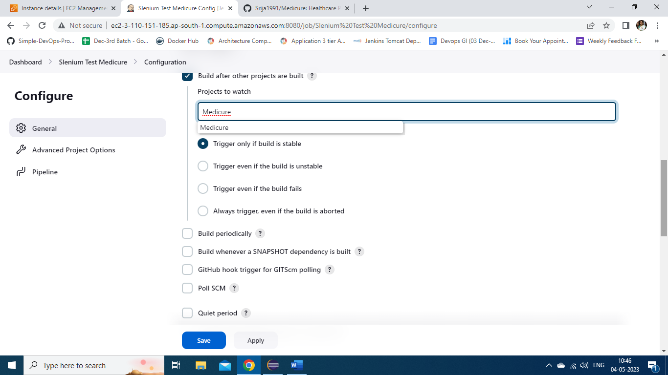

Here is the pipeline script to execute the jar on EC2 instance.

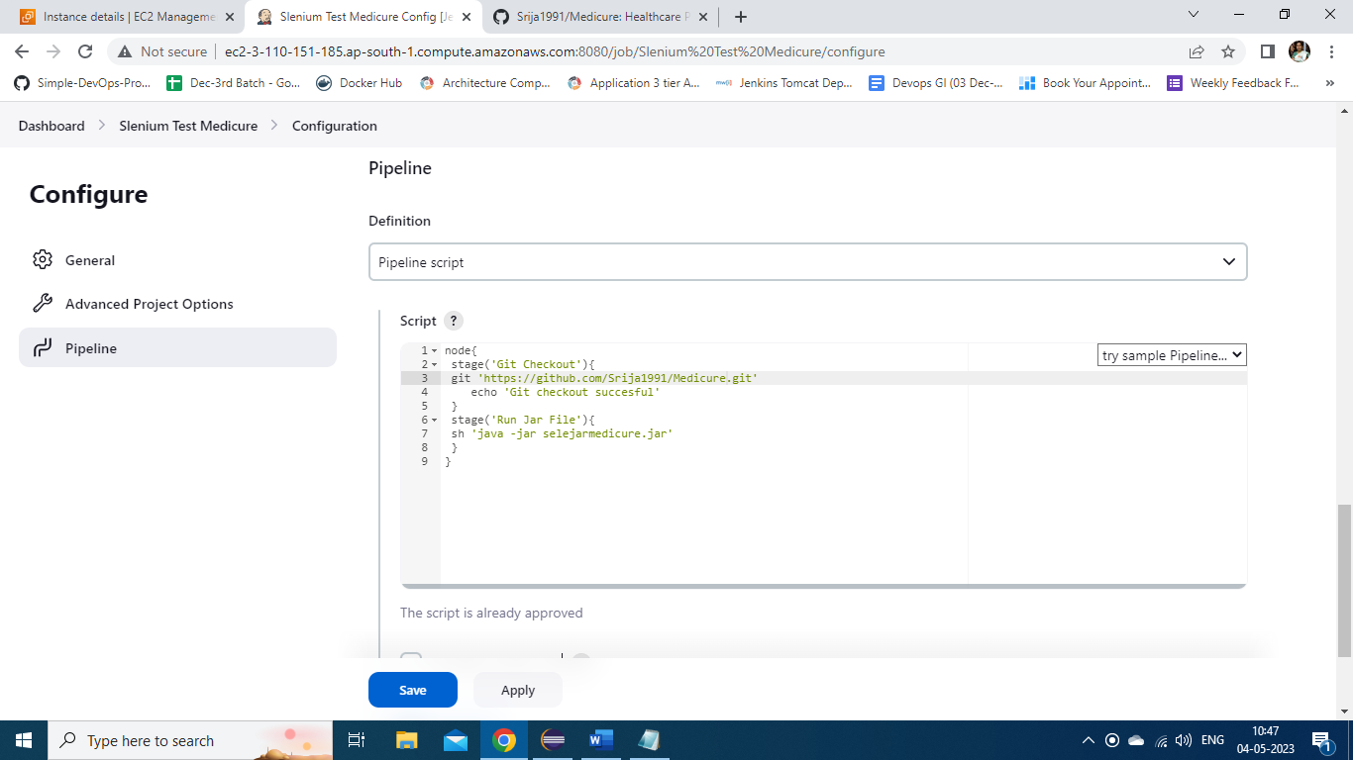

The console output for this job is shown here. It shows the chrome is started successfully and script is executed successfully.

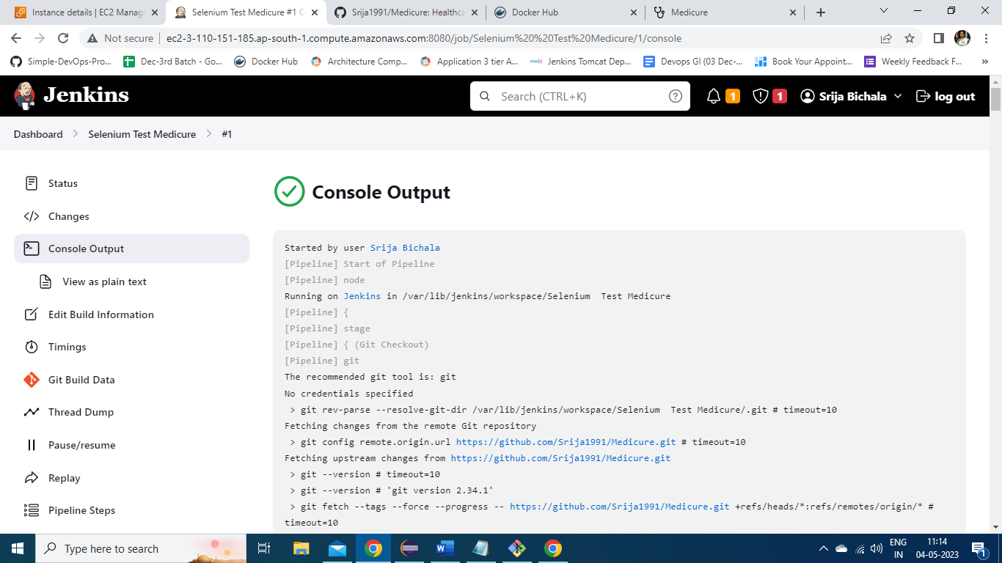

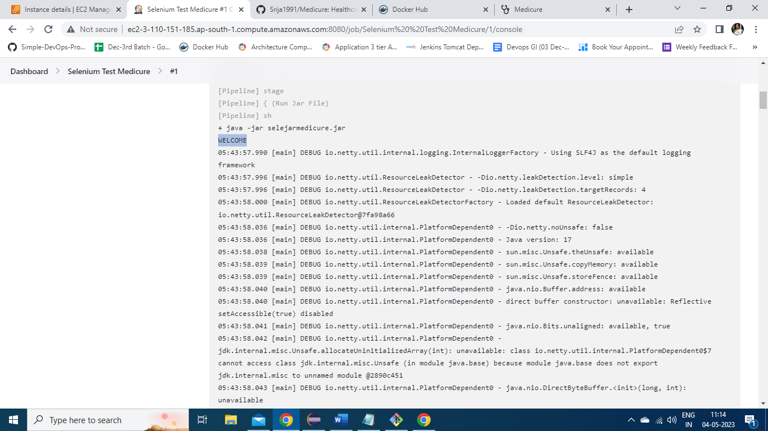

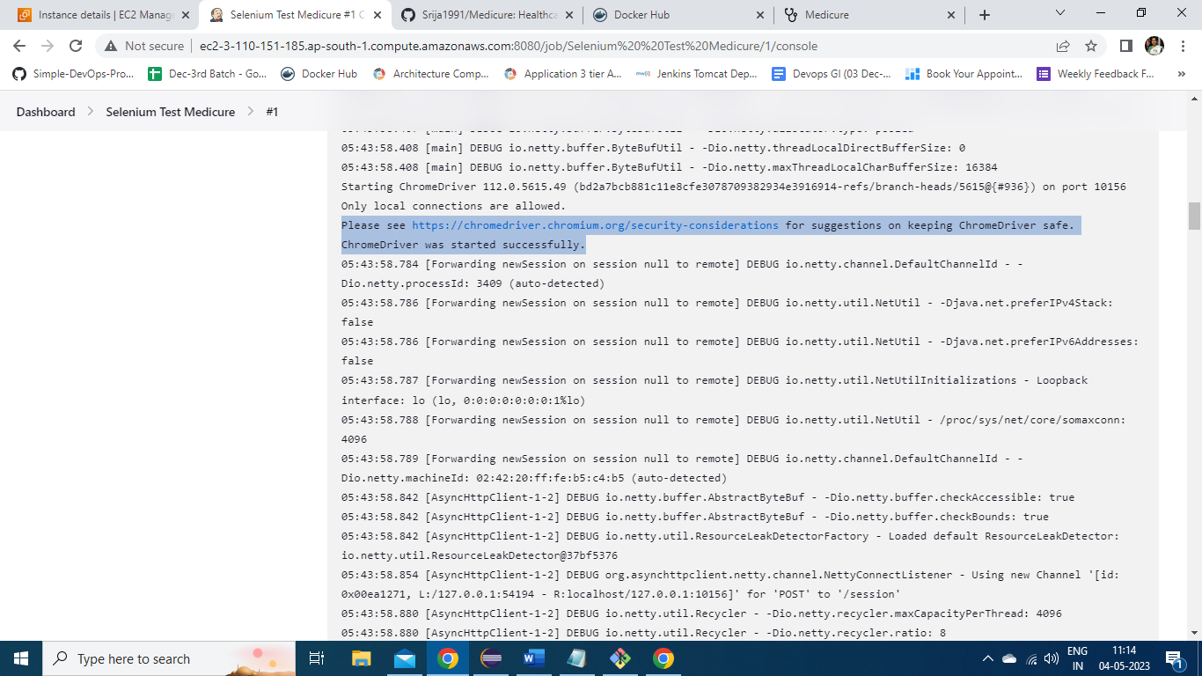

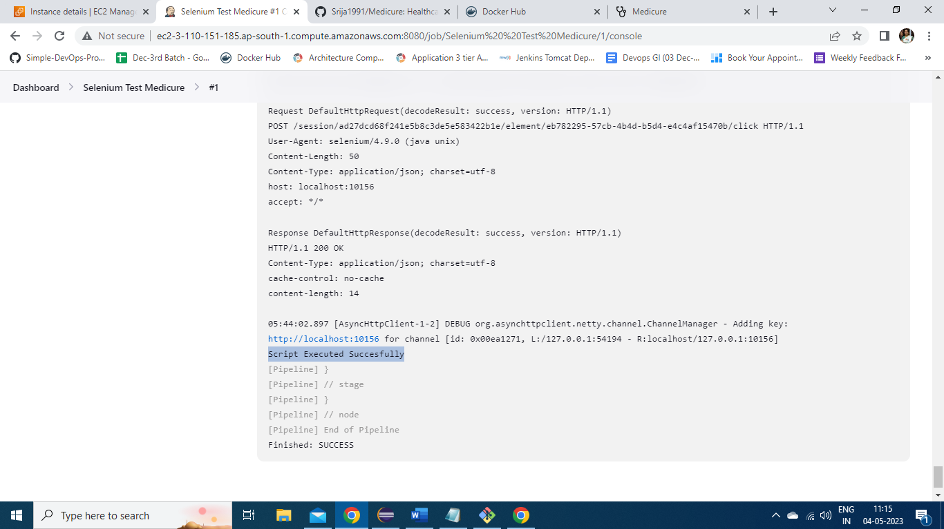

After successful execution of Selenium script, a new job named *Prod_server_Terrfaorm* is created to create Production server using terraform.

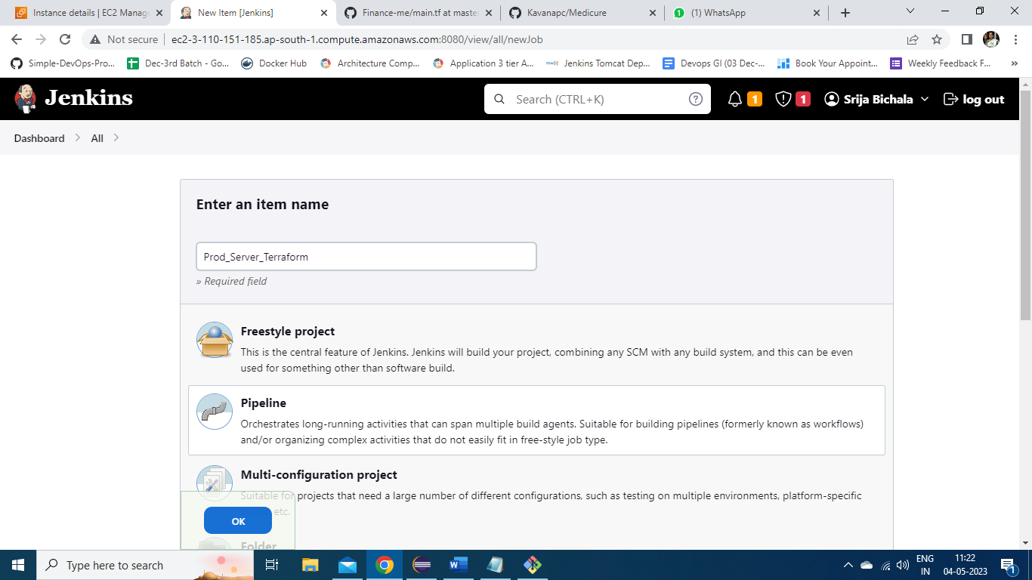

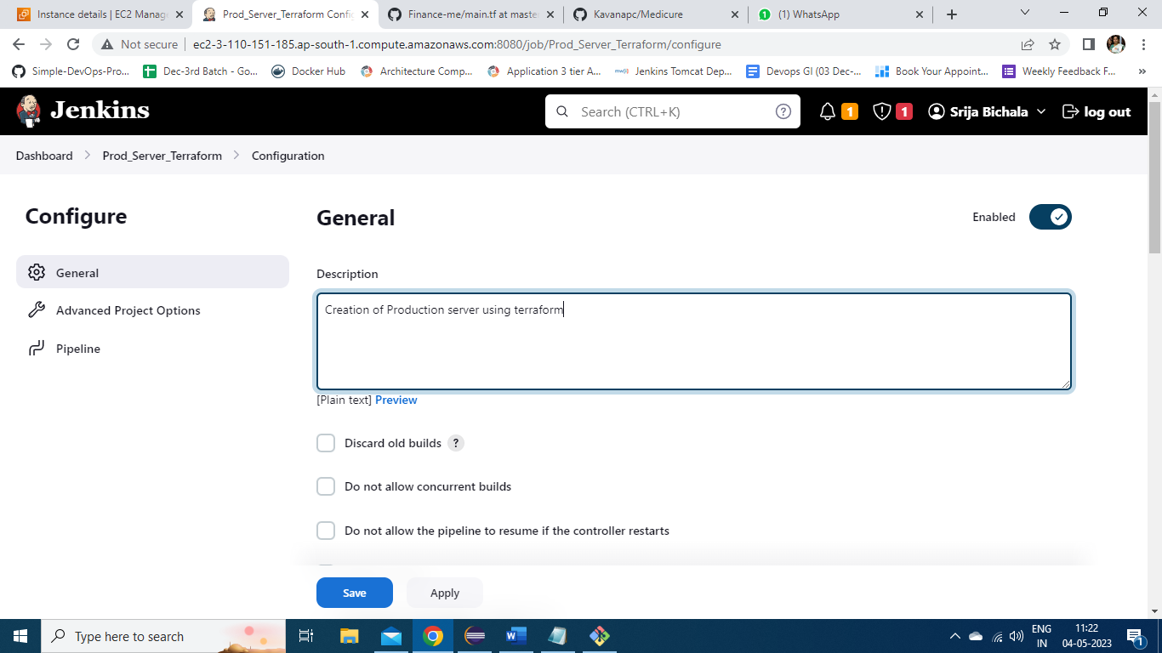

The pipeline script for this is provided through *JenkinsFile2* on the github.

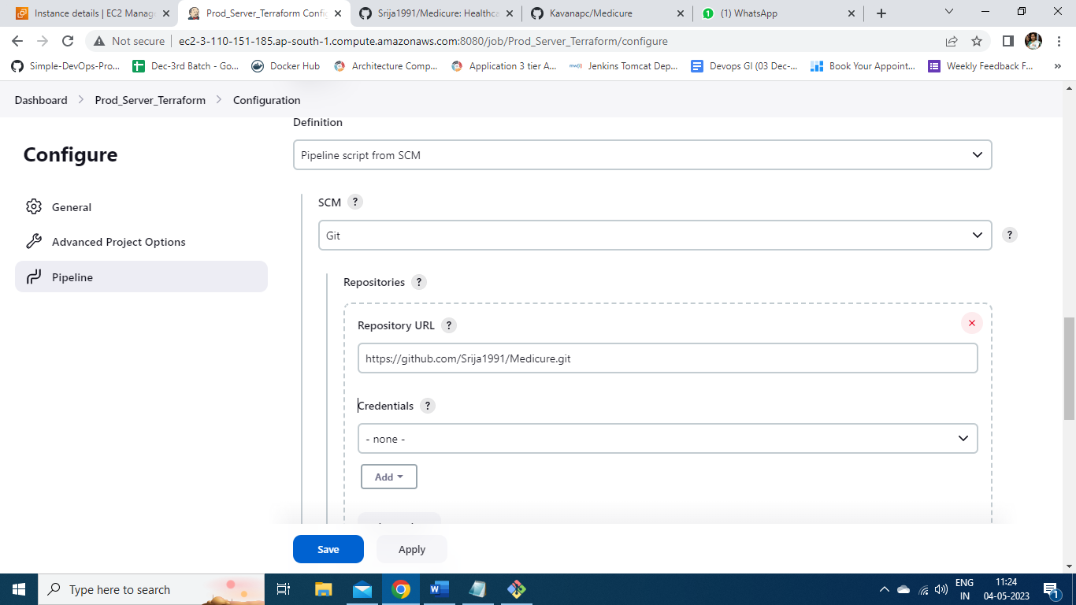

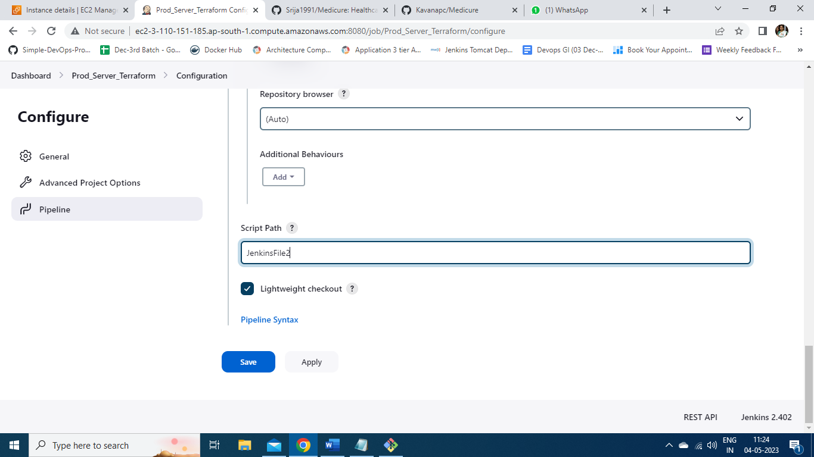

Here is the script to create new instance of t2.medium.

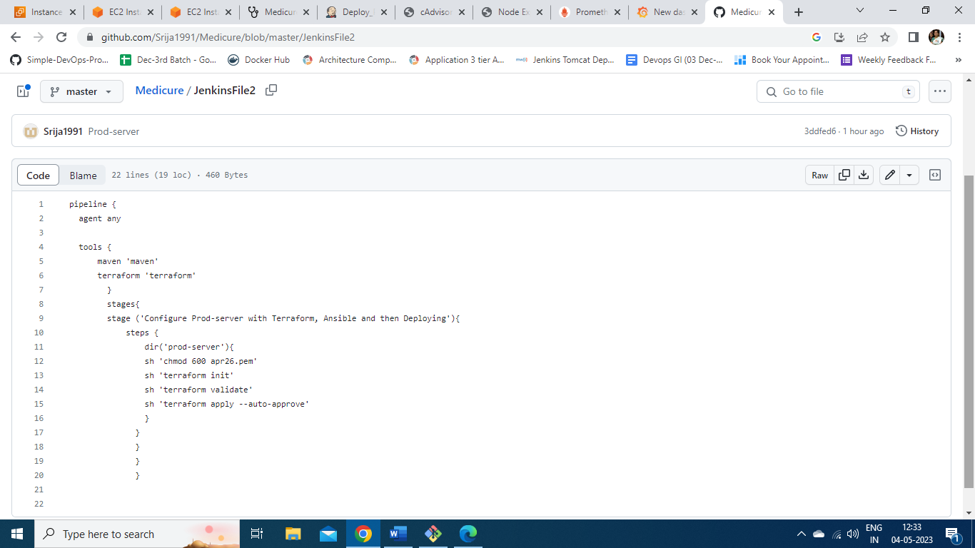

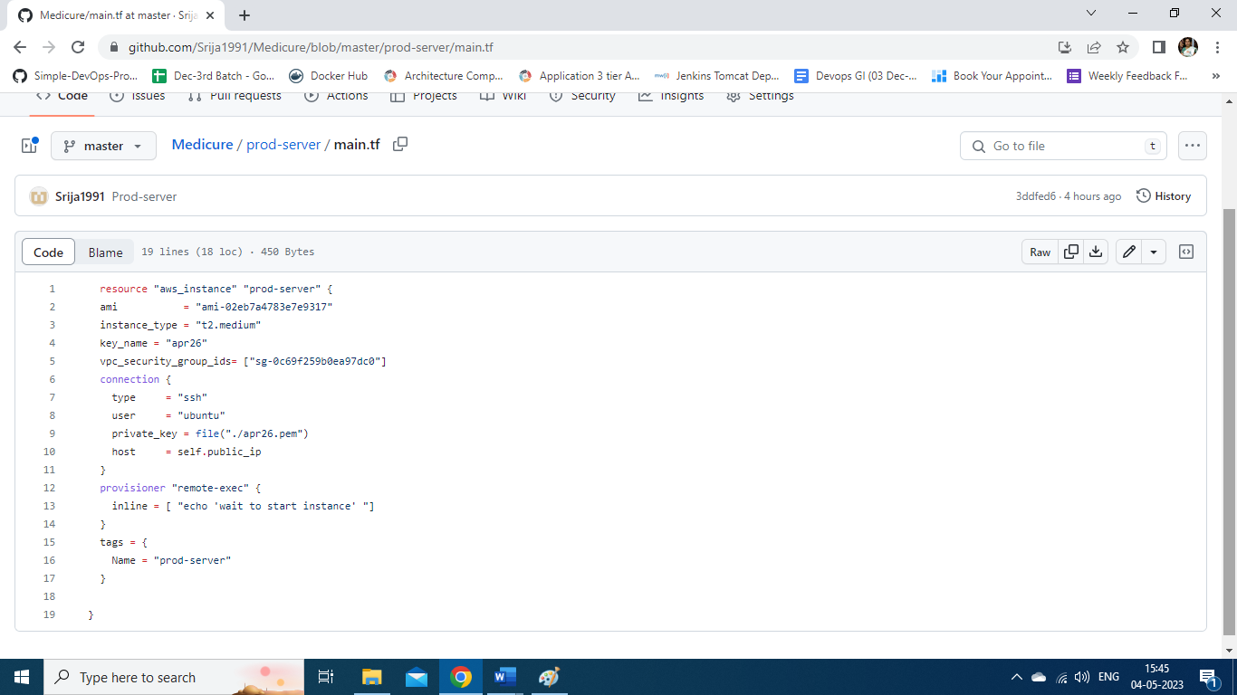

Now the job is executed and it is success creating a t2.medium instance which is manually configured for Kubernetes setup, since the project need to deploy using Kubernetes-cluster upon successful testing.

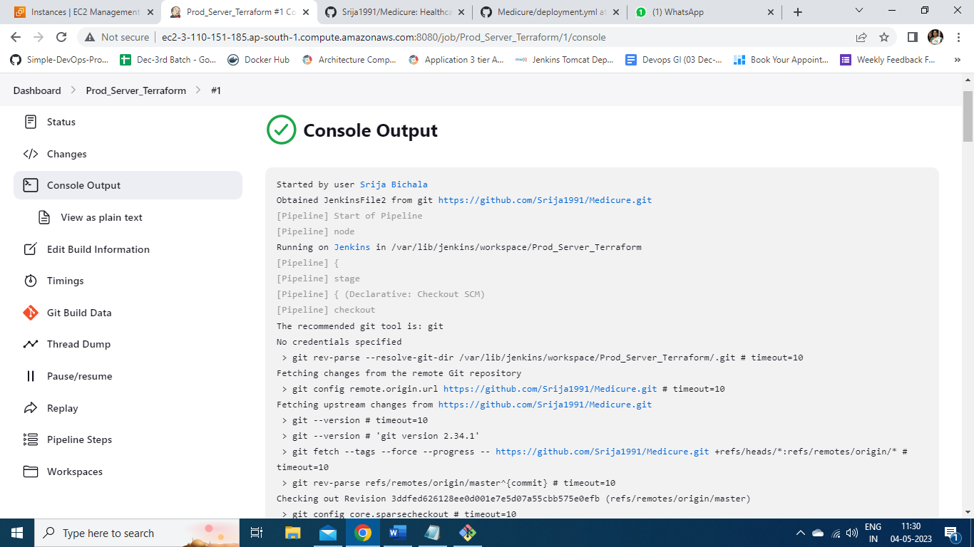

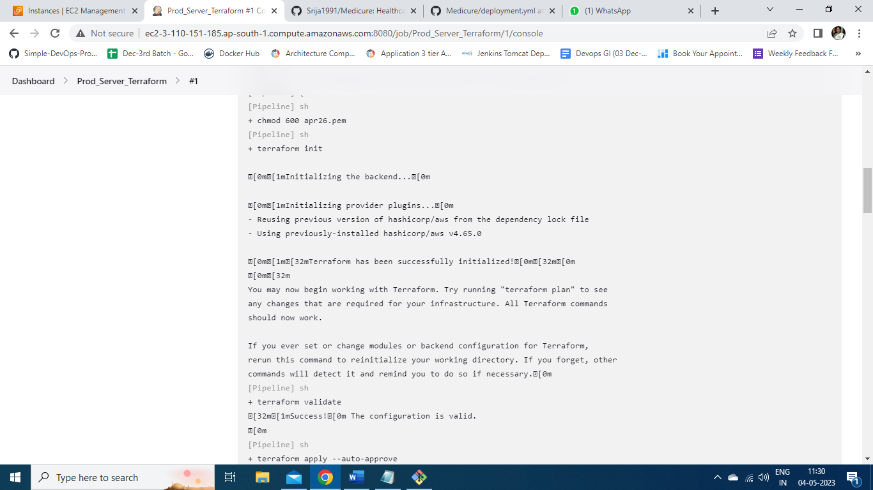

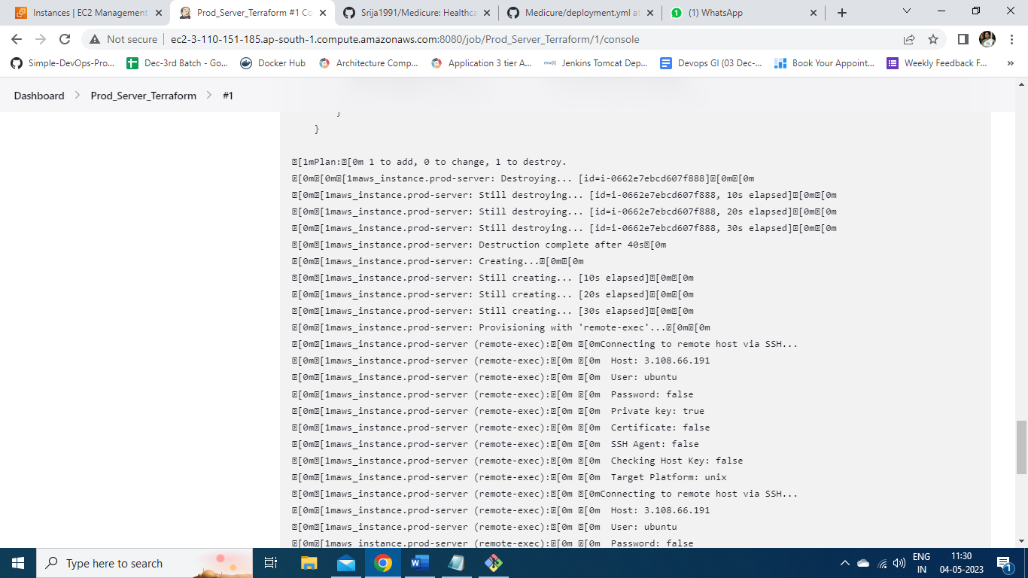

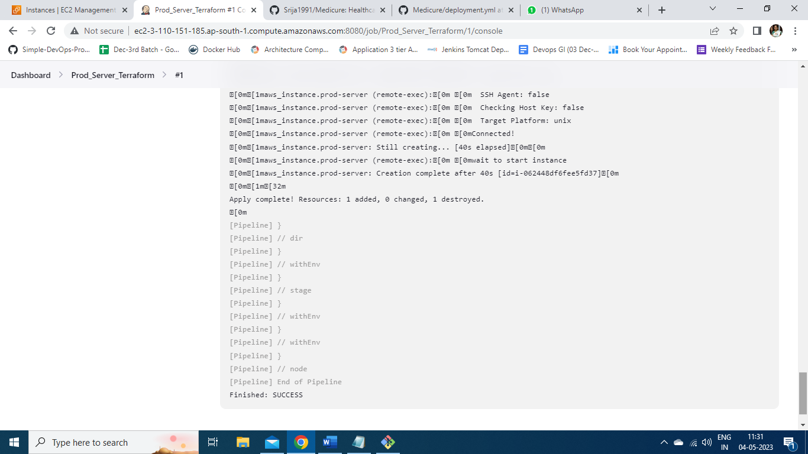

Here is the prod-server created and its specifications are shown here.

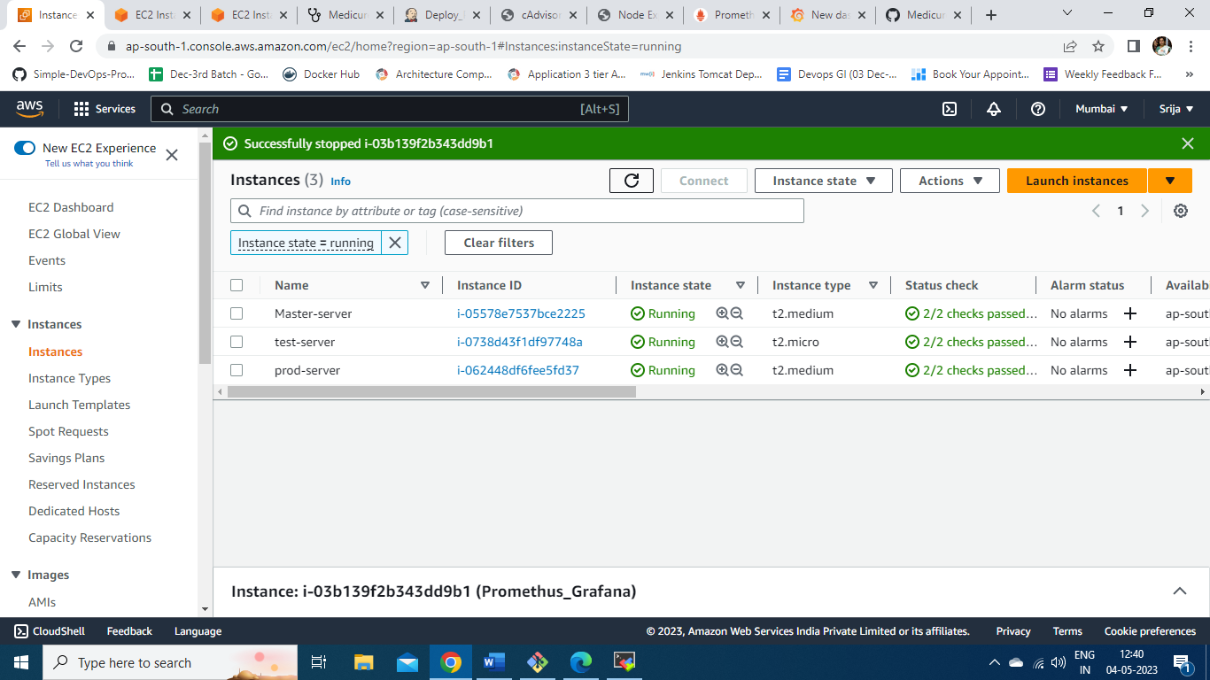

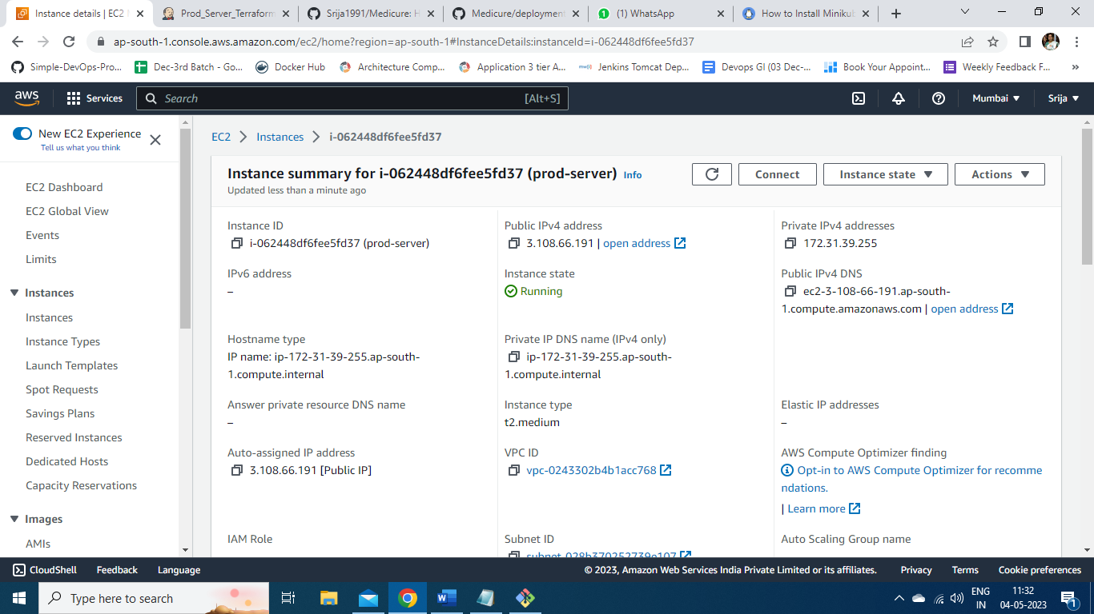

The prod-server is configured through Kubernetes setup and now to deploy the application through cluster a new job is created namely *Deploy_Prod_server.*

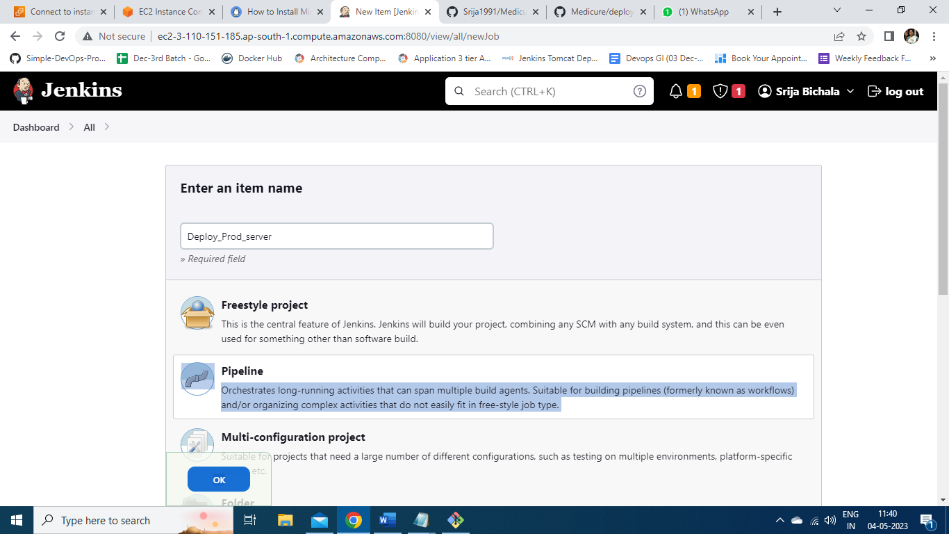

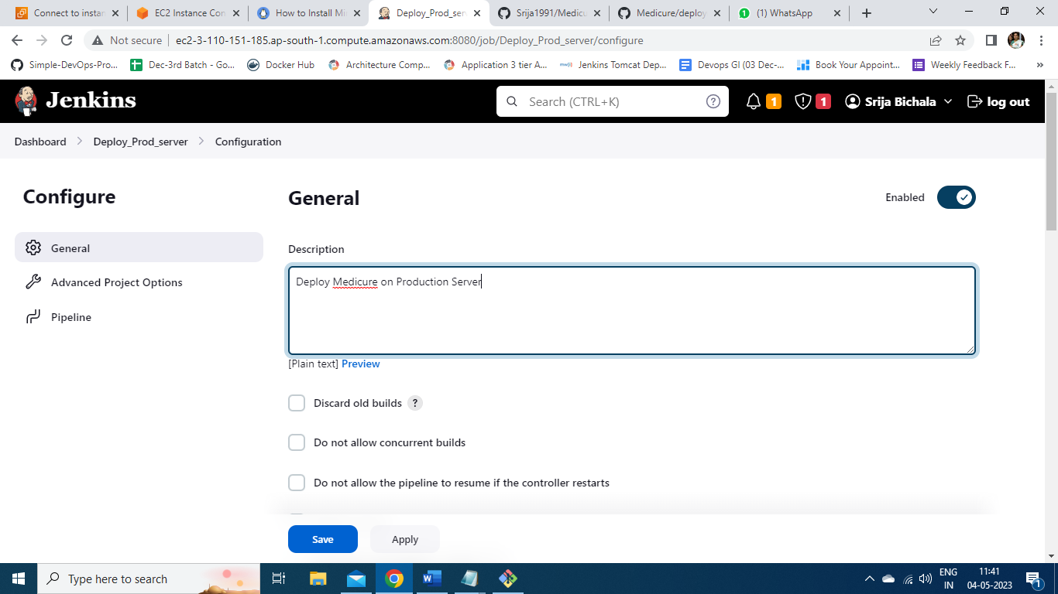

Here is the pipeline script to deploy through Kubernetes.

Stage : Create SSH connection and apply the deployment.yml file

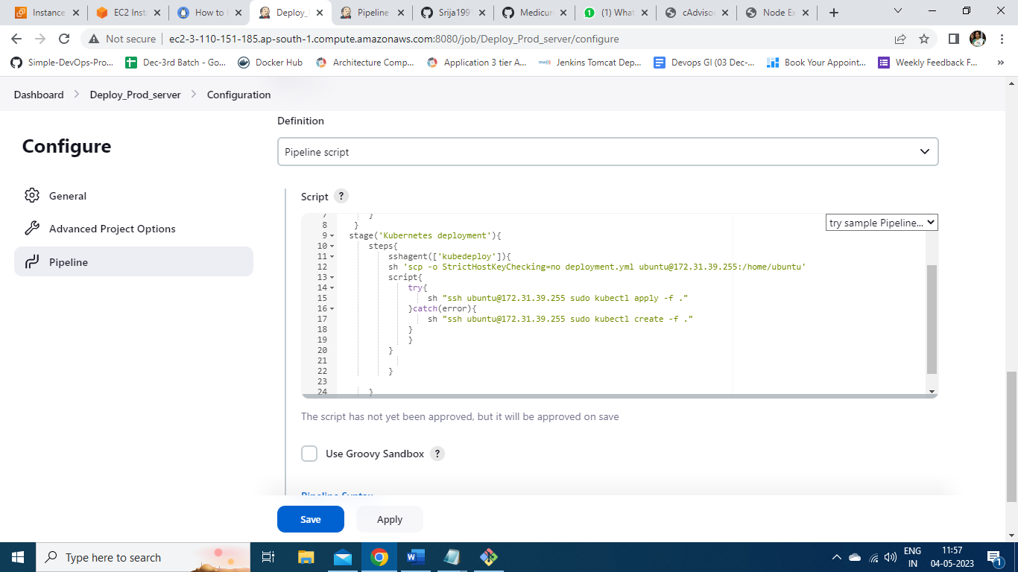

Here is the deployment.yml file pushed onto git repo.

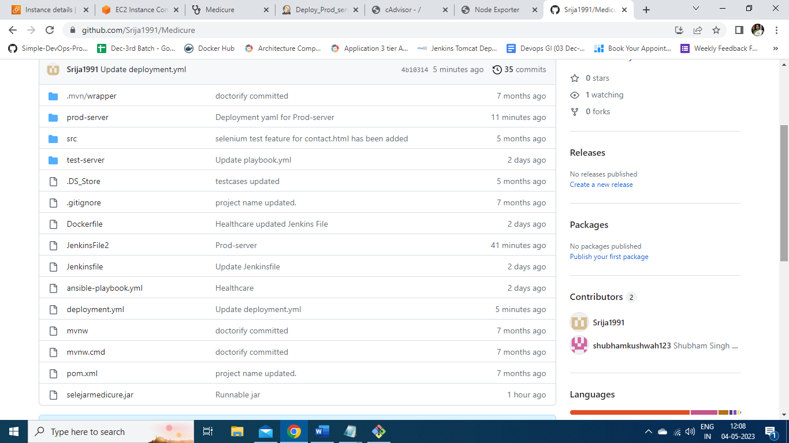

The deployment.yml file to create deployment using Kubernetes cluster with scaling factor 2, and using Nodeport service to deploy on port 31000.

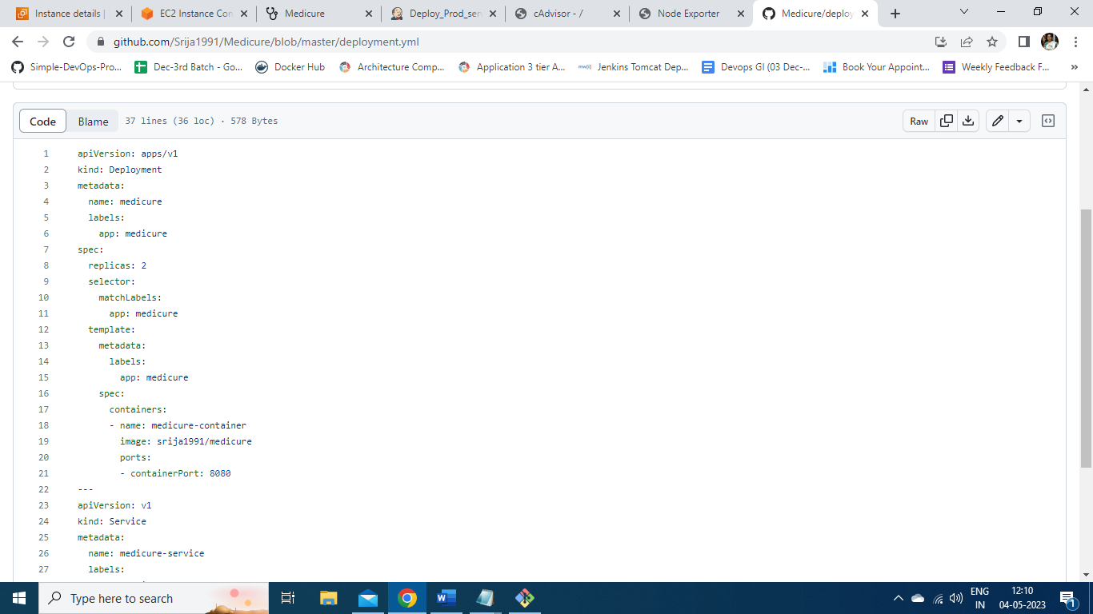

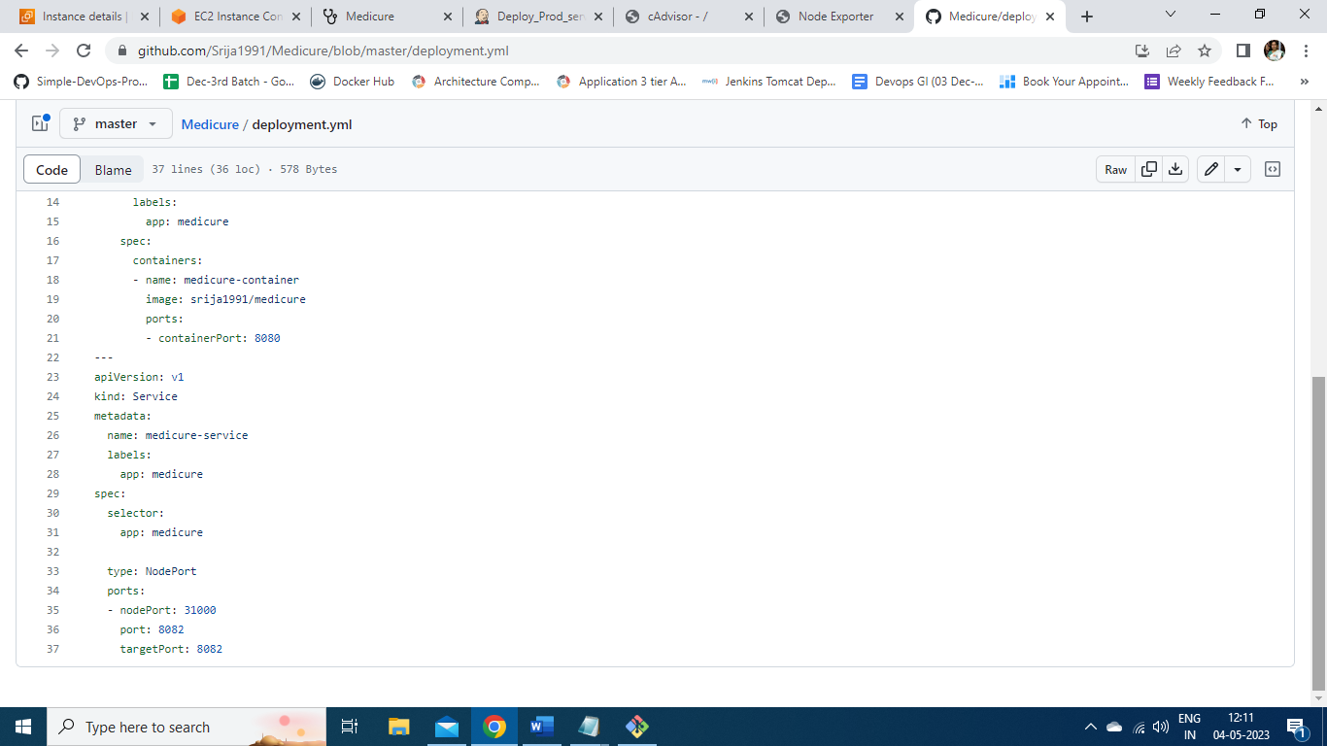

The job is run successfully and here is the console output .

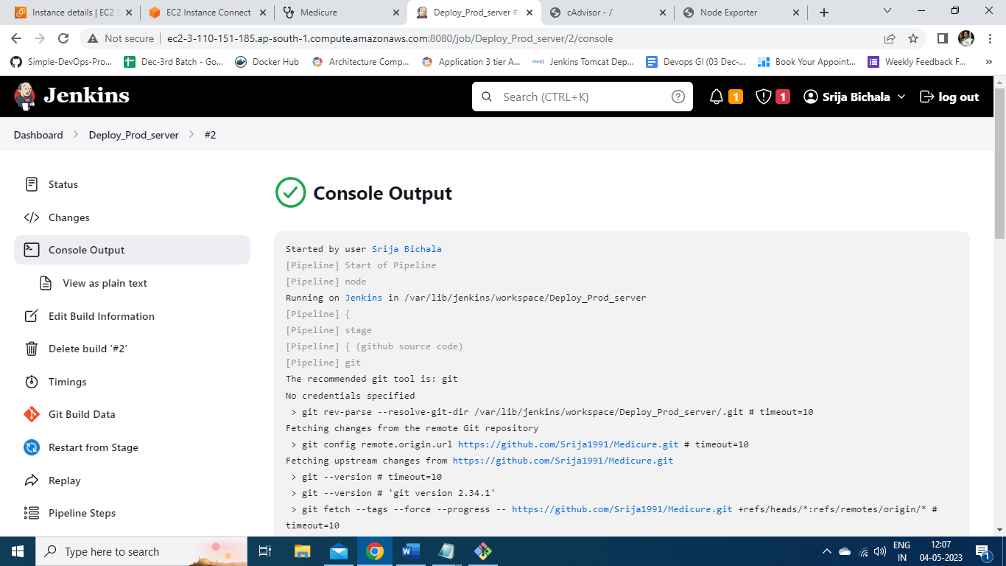

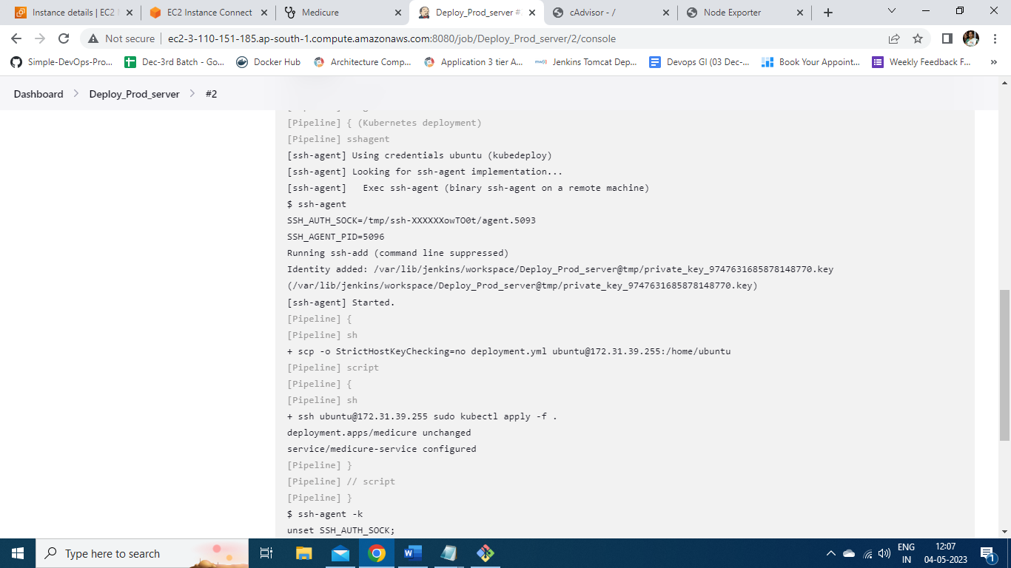

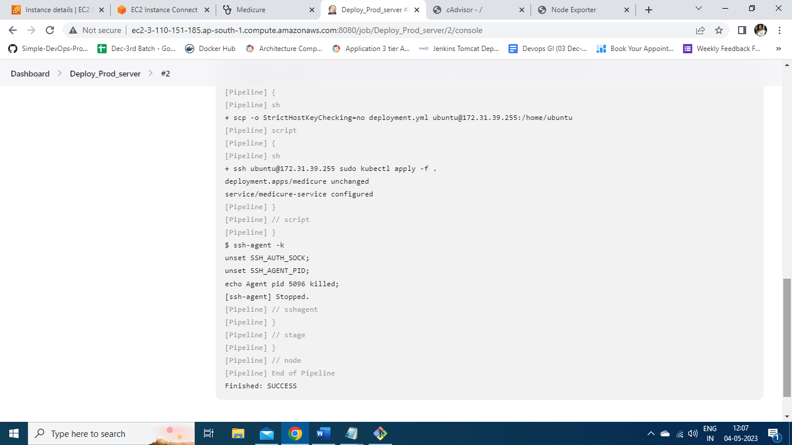

The prod-server is manually entered and checked for the pods and deployments using command *kubectl get all* . Here we can see the deployments 2/2 running stating that two pods are created using cluster on the port 31000. IP address of prod_server is 3.108.66.191.

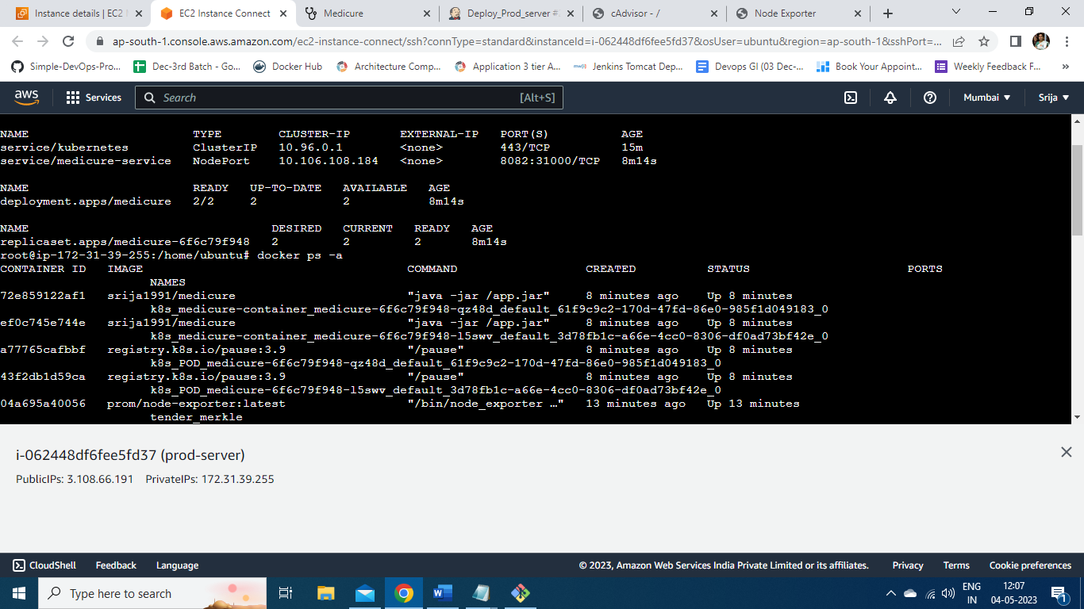



On the same production server cAdvisor and Node-exporter containers are started to take the metrics for monitoring using Prometheus and Grafana.

Here is the cAdvisor running on port 8080 on production server.

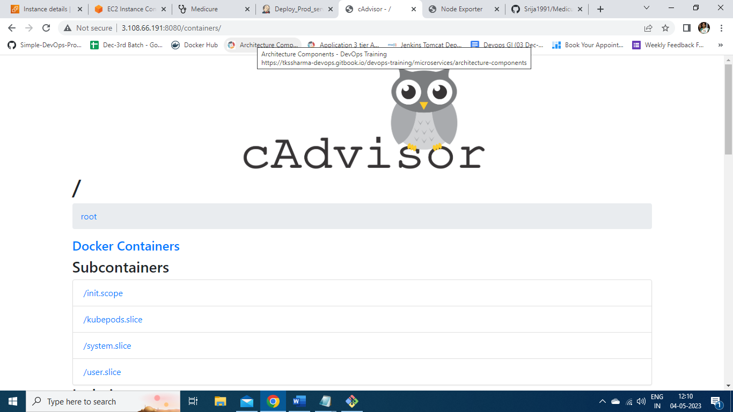

Here is the Node-exporter running on port 9100 on prod_server.

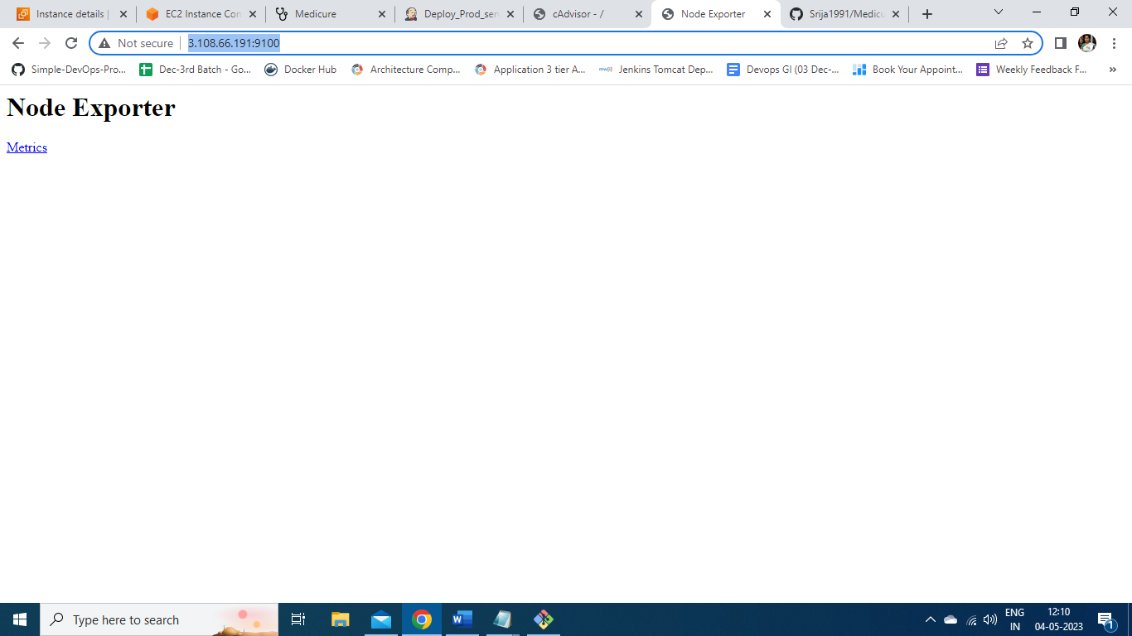

Now Prometheus_Grafana Server is configured to monitor the production server.

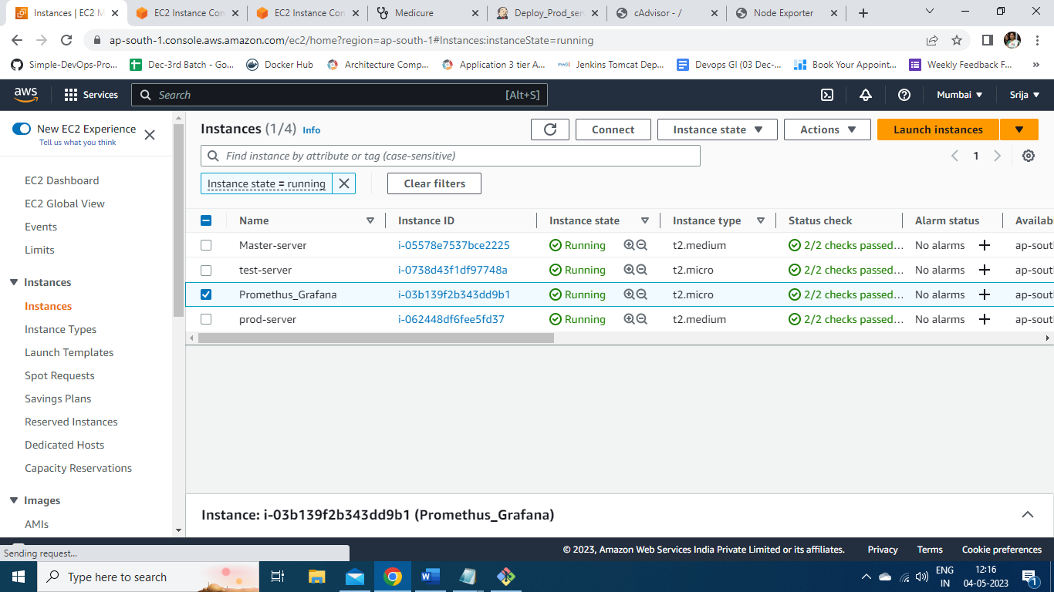

Here is the Instance summary of the monitoring server.

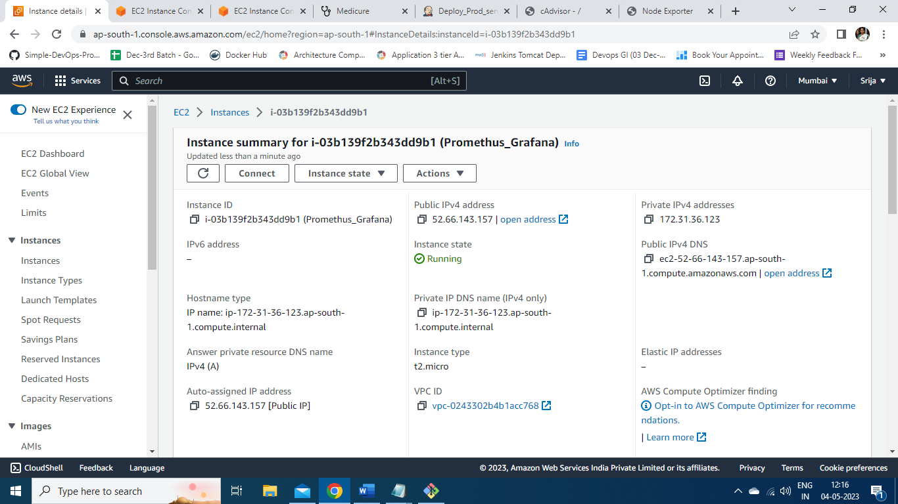

The monitoring server is configured by adding the IP address of cAdvisor and node-exporter available from production server in the *prometheus.yml* file.

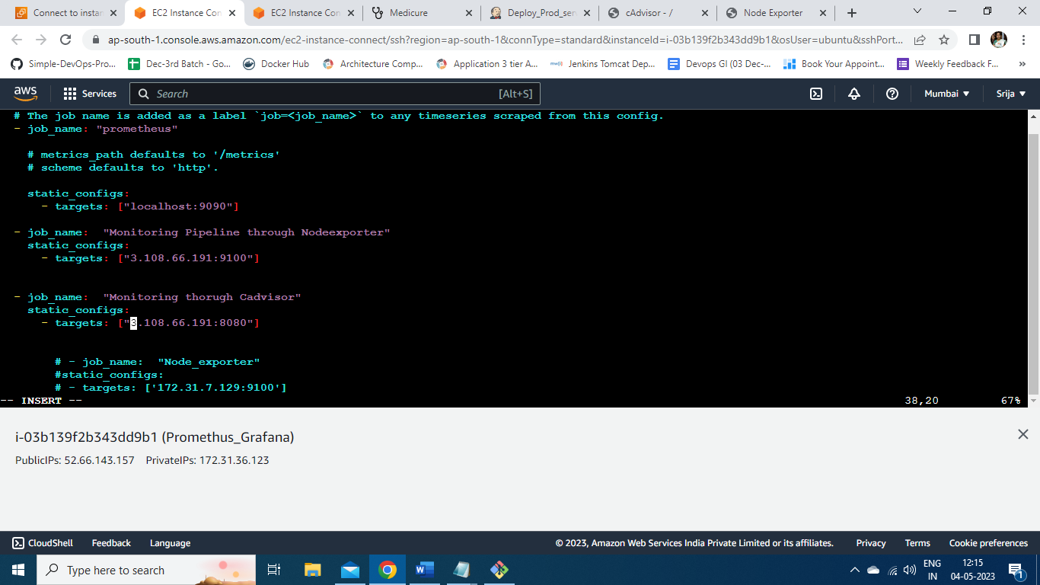

The Prometheus is started using command ./prometheus.

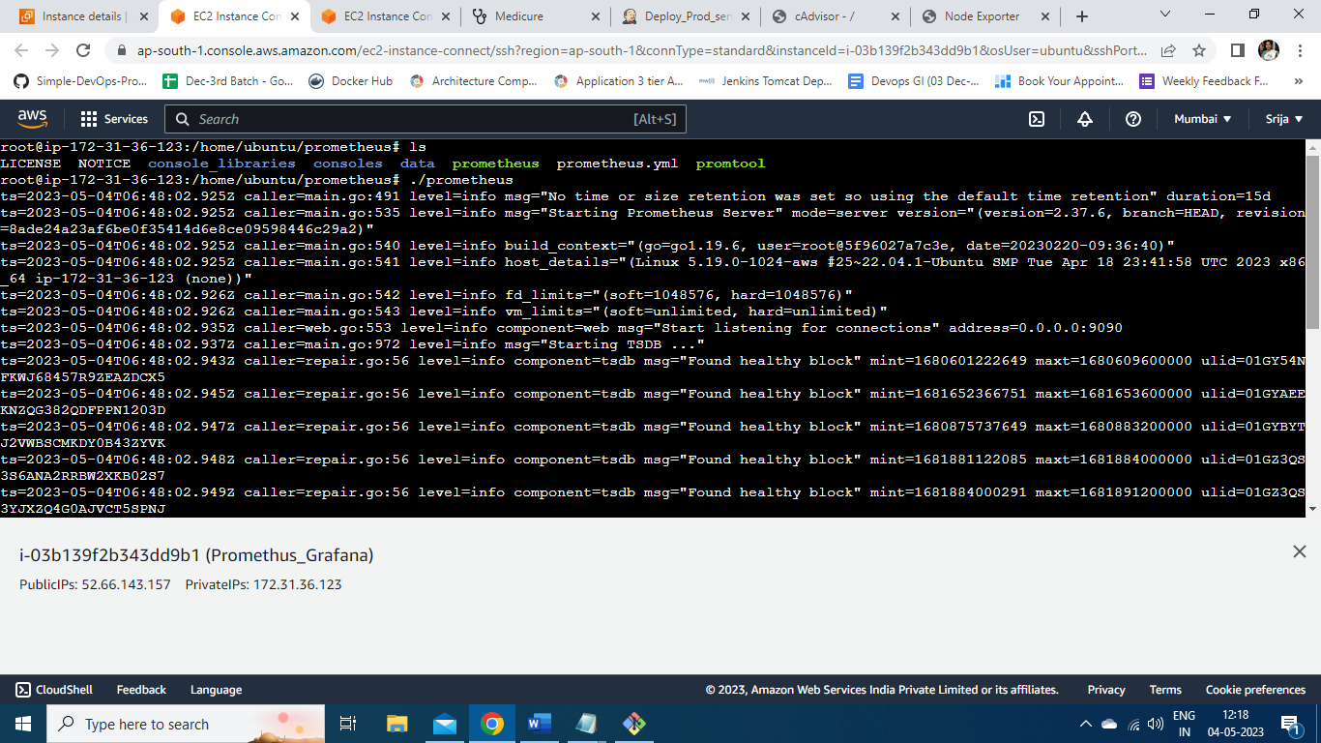

Here we can see the metrics are added as Prometheus targets on port number 9090 of monitoring server successfully and are available to monitor.

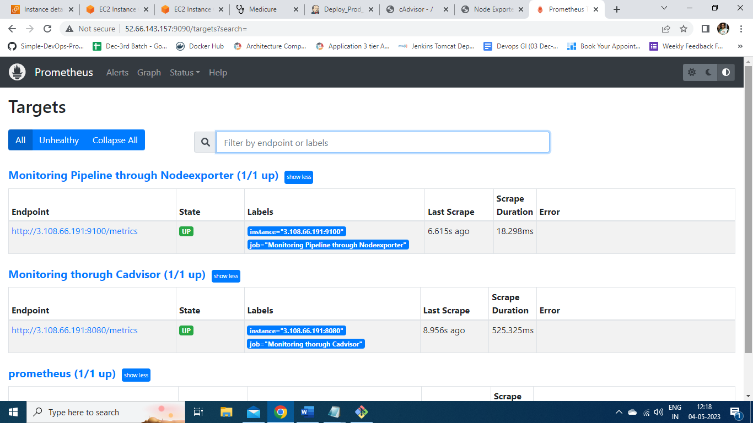

From the monitoring server port number 3000 is allocated to Grafana monitoring and logged in to monitor.

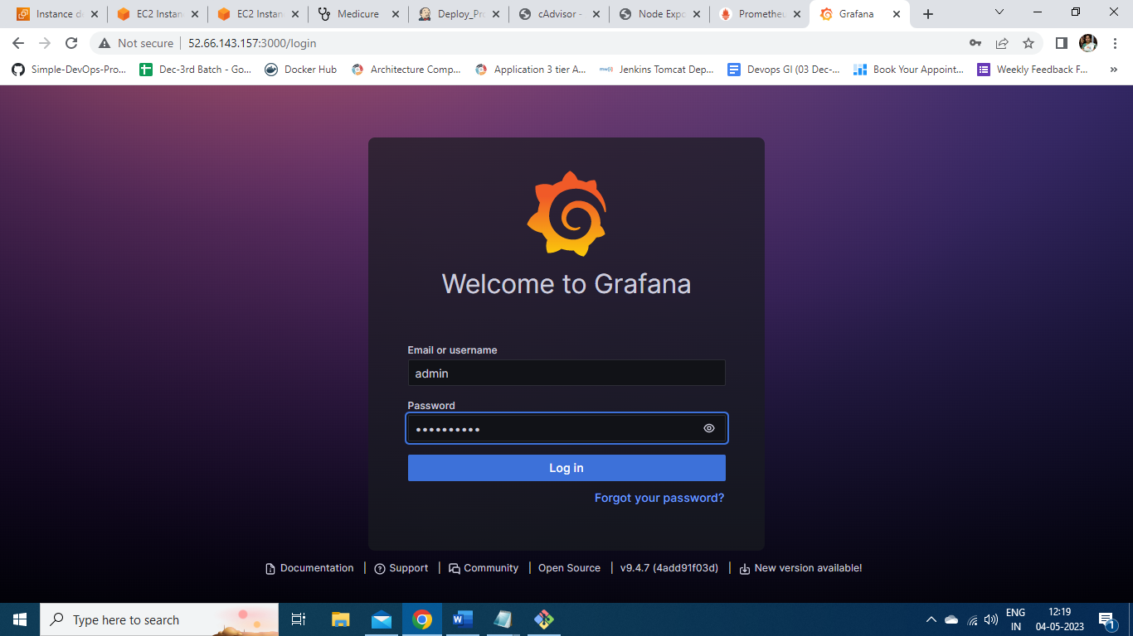

A new datasource is added named prometheus6 and configured to collect metrics.

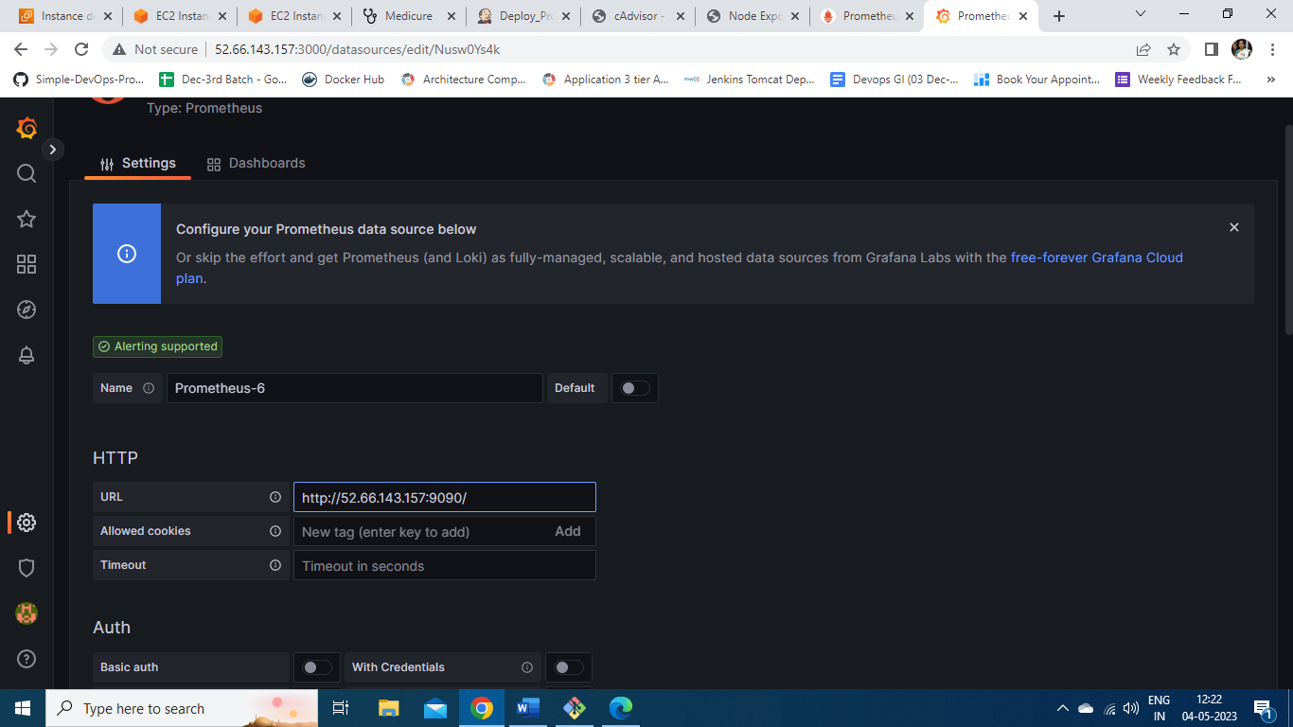

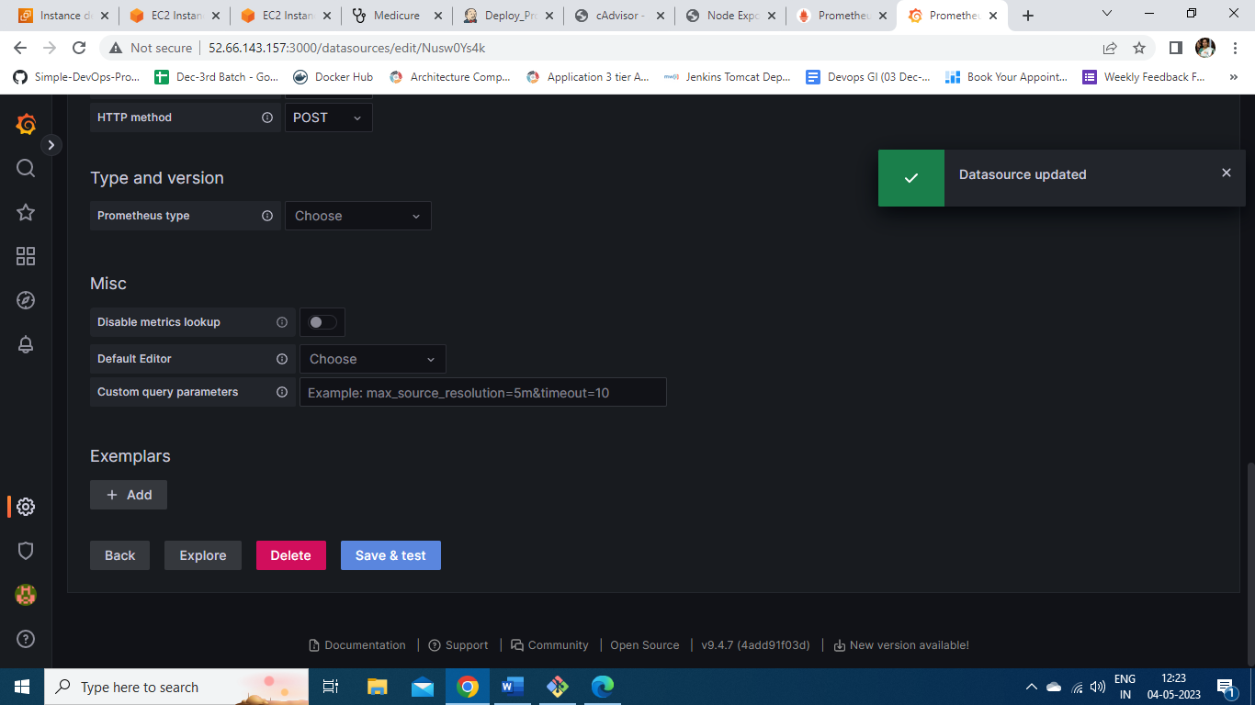

Now a Dashboard is created and a query called node_cpu_usage is run and monitored.

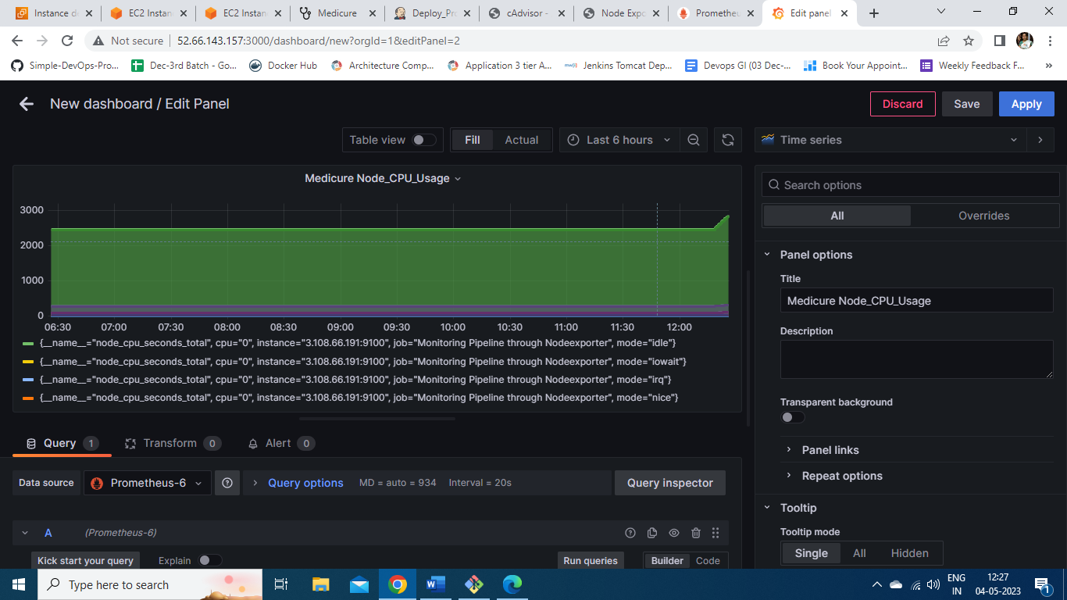

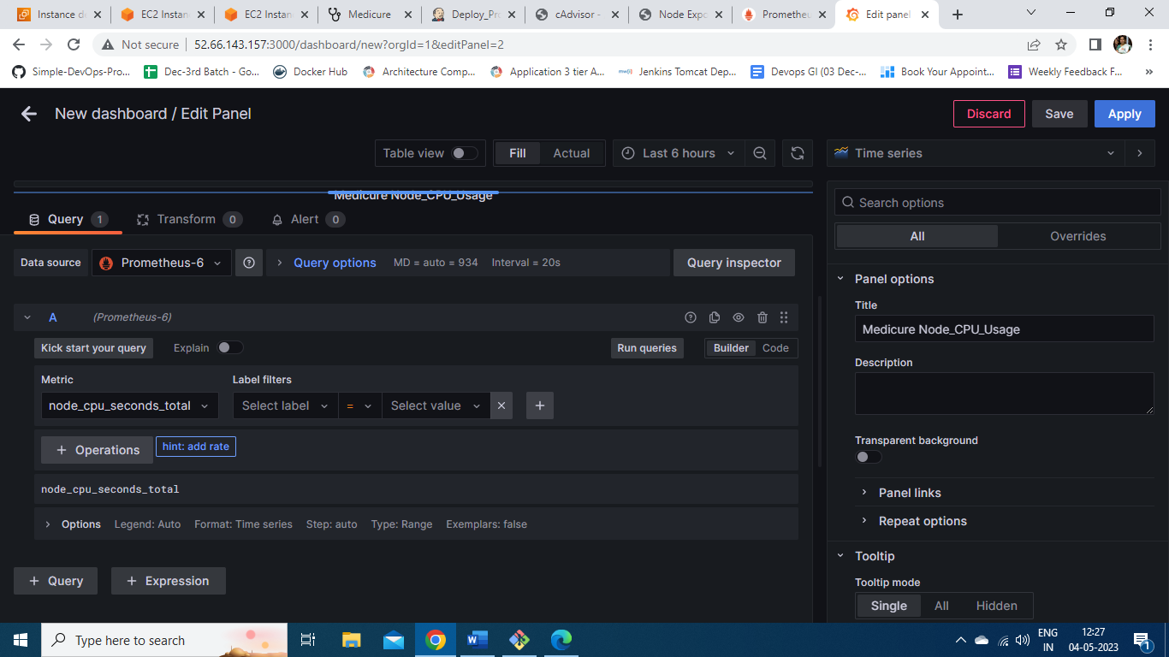

Here is graph showing the query container_cpu_uasge.

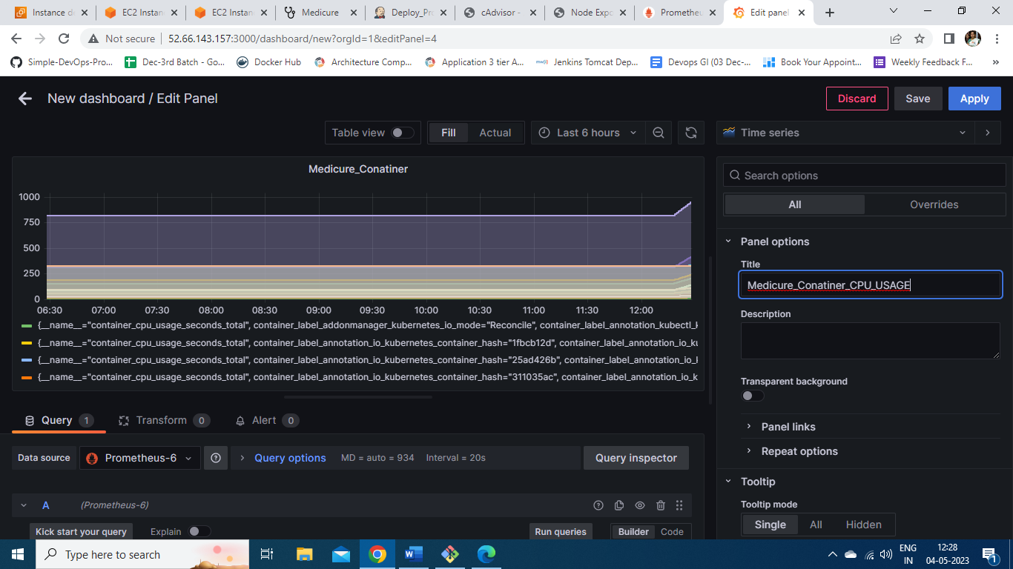

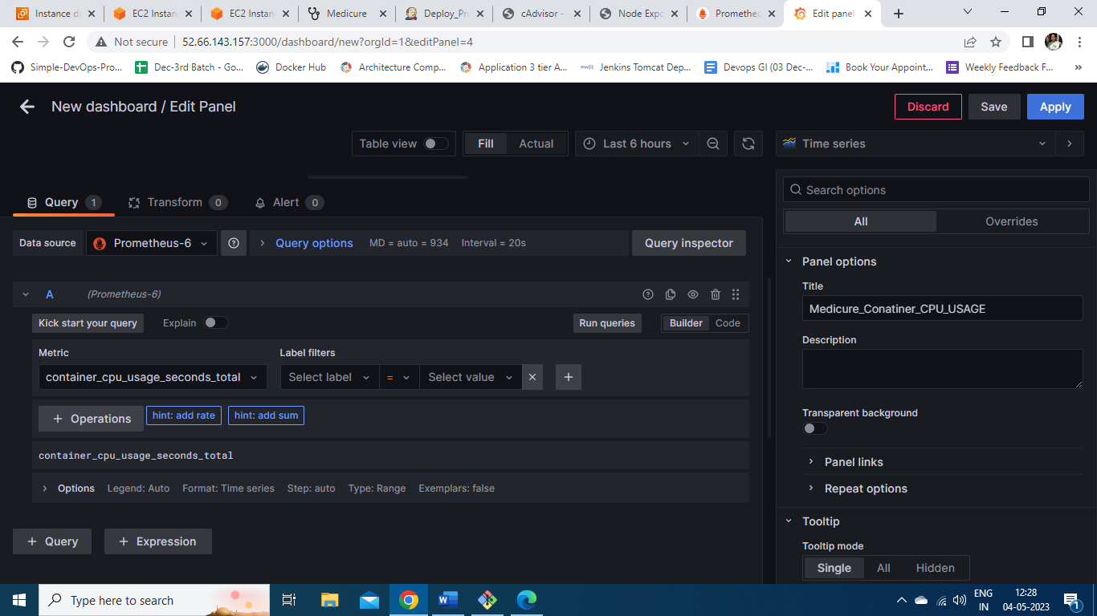

The dashboard for monitoring CPU usgae is shown here.

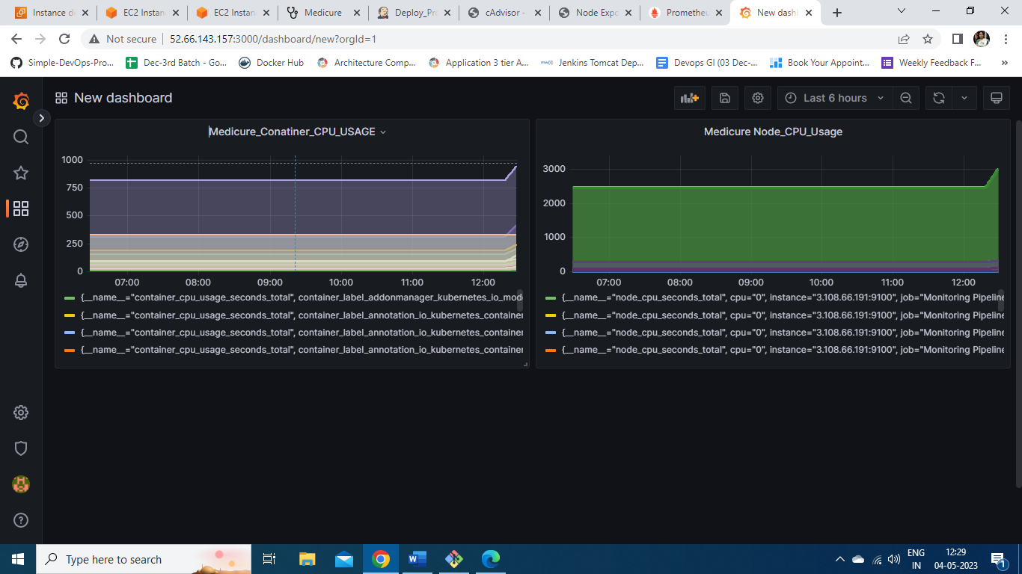

**THANK YOU**